Jardin, Gabrielle Anne P.
Miranda, Kian Andrei L.
Refrea, Mar John S.
Soriano, France Hedrich O.

3-ITB

PROF. JOSEPH D. CARTAGENAS
ENHANCING LEGAL PRACTICE MANAGEMENT: A SYSTEM FOR CASE HANDLING, FILE MANAGEMENT, AND AUDIT TRAILING AT OPINA LAW OFFICE
i

A Capstone Project Proposal
Submitted to the
Faculty of The College of Computing Studies
PAMANTASAN NG CABUYAO
City of Cabuyao, Laguna

In Partial Fulfillment
of the Requirements for the Degree
BACHELOR OF SCIENCE IN INFORMATION TECHNOLOGY

By:
Jardin, Gabrielle Anne P.
Miranda, Kian Andrei L.
Refrea, Mar John S.
Soriano, France Hedrich O.

April 2025
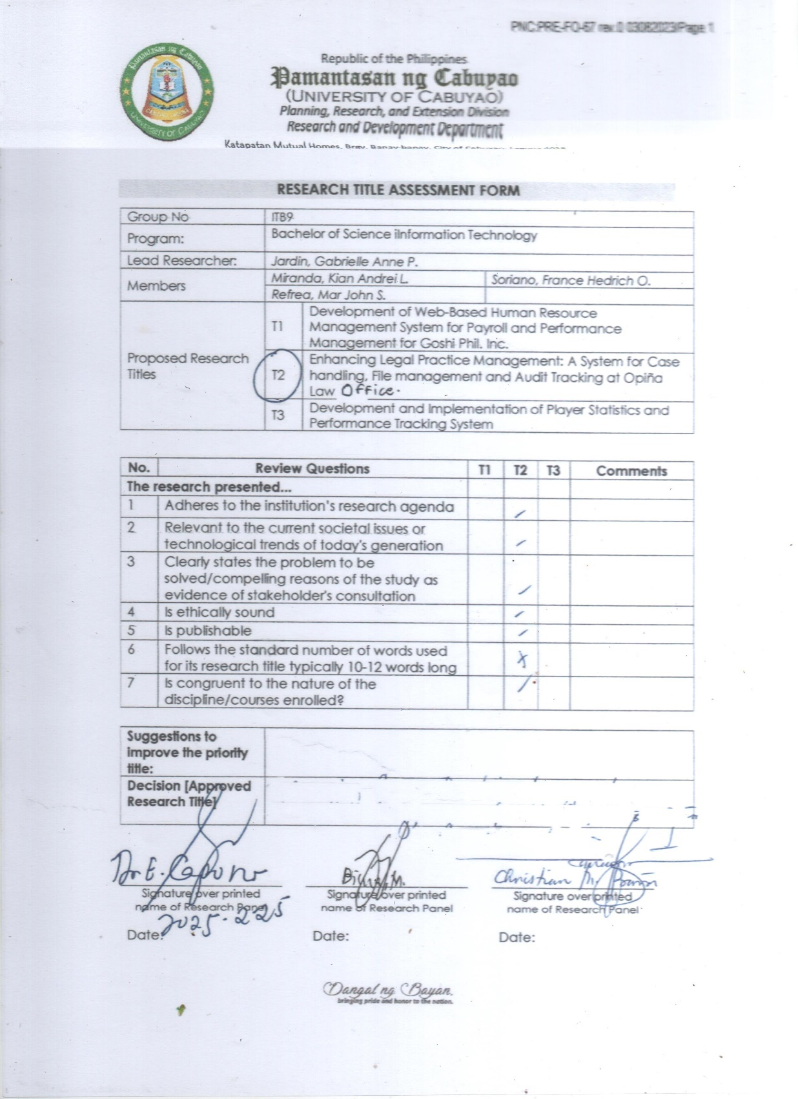
PNC: Form 67 Research Title Assessment Form
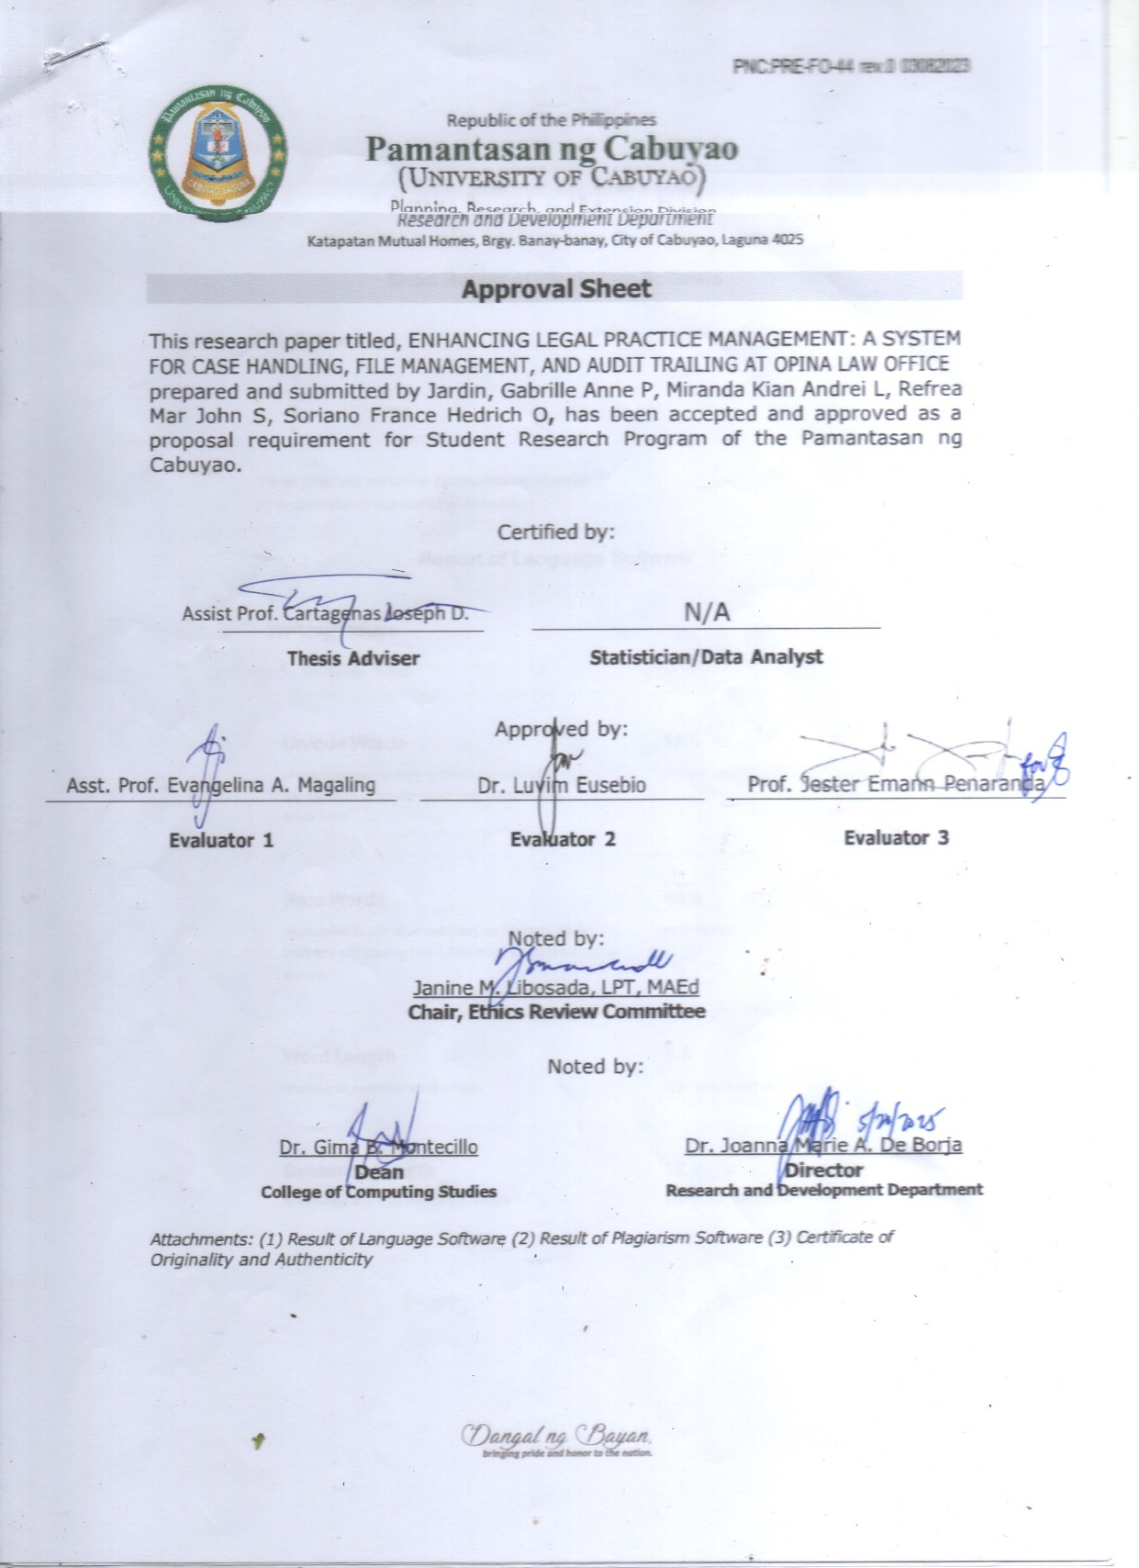
PNC: Form 44 Approval Sheet
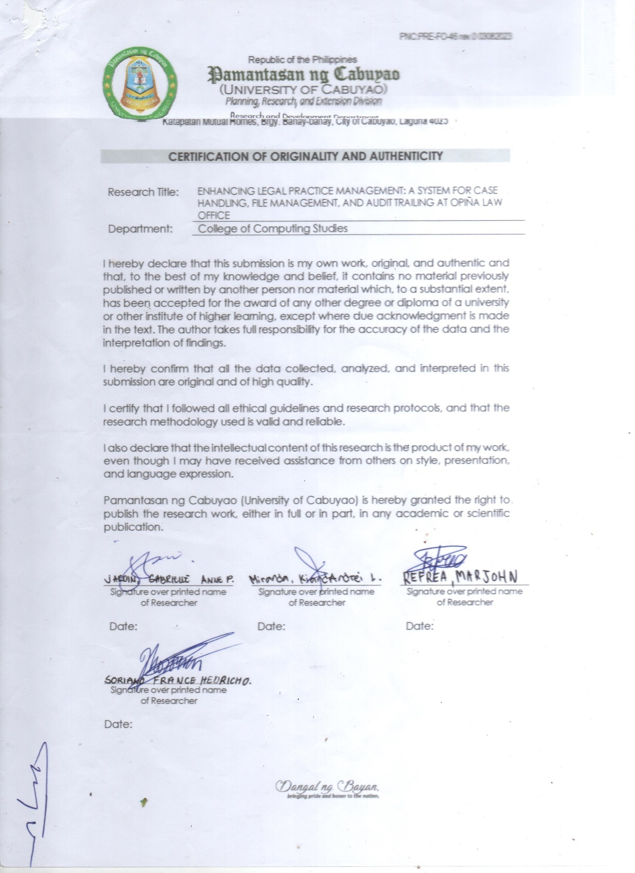
PNC: Form 46 Certification of Originality and Authenticity
Table of Contents
ii

Title Page i
Table of Contents ii
List of Figures iv
List of Table v

Page
CHAPTER I- The Problem and Its Settings
Introduction..................................................................................................1
Objectives of the study…………………………………………………………2
Scope and Limitation……………………………………………………………4
Significance of the Study……………………………………………………....5
Definition of Terms…………………………………………………………..….6
Conceptual Terms…………………………………………………........
Technical Terms………………………………………………………....8
CHAPTER II-Review Related Literature and Studies
Introduction................................................................................................10
Conceptual Literature………………………………………………………….
Research literature……………………………………………………………..12
Review of Related Literature…………………………………………
Review of Related Study………………………………………………14
Theoretical/ Conceptual Framework………………………………………..16
Theoretical……………………………………………………………….
Conceptual Framework………………………………………………..
Conceptual Paradigm………………………………………………………….18
Synthesis………………………………………………………………………...20

CHAPTER III- Methods and Procedures
iii
Introduction................................................................................................22
Research Design……………………………………………………………….
Respondents of the Study……………………………………………………23
Population and Sampling……………………………………………………..25
Data Gathering Procedure……………………………………………………
Data Gathering Tools………………………………………………………….26
Evaluation and Scoring……………………………………………………….30
Data Analysis Plan ……………………………………………………………..31
System Development………………………………………………………….32
System Design………………………………………………………………….34
Use Case Diagram……………………………………………………...
Activity Diagram...……………………………………………………...43
Class Diagram…………………………………………………………..56
Ethical Considerations…………………………………………..…………....57
References………………………………………………………………………58
Appendices……………………………………………………………………...68
Confidentiality and Non-Disclosure Agreement………………….
Letter for Client…………………………………………………………71
Short Report of Plagiarism Software……………………………….72
Report of Language Software………………………………………..

List of Figures
iv
Page

Figure 1: Agile Process Model……………………………………………....17
Figure 2: Conceptual Paradigm……………………………………………..19

System Design
Use Case Diagram
Figure 3: Case Tracking……………………………………………………..34
Figure 4: File Management and Document Storage……………………35
Figure 5: Scheduling and Calendar……………………………………….
Figure 6: Audit Trailing………………………………………………………36
Figure 7: Advance Security Features for Admin and…………………..37
Attorney
Figure 8: Advance Security Features for Client……………………...…38
Figure 9: Use Case Diagram for E-filing Links…………………….…….39
Figure 10: Legal Document Generation…………………………….…….40
Figure 11: Account Management for all of the user.............................41
Figure 12: Client Management................................................................42
Figure 13: Employee Management.........................................................

Activity Diagram
Figure 14: Case Tracking........................................................................44
Figure 15: File Management and Document Storage...........................45
Figure 16: Scheduling and Calendar.....................................................46
Figure 17: Audit Trailing.........................................................................47
Figure 18: Advanced Security Feature for Admin and........................48
Attorney
Figure 19: Advanced Security Feature for Client.................................49
v
Figure 20: E-filing Links..........................................................................50
Figure 21: Legal Document Generation Module...................................51
Figure 22: Account Management of all Users.......................................52
Figure 23: Client Management................................................................53
Figure 24: Employee Management.........................................................54

Class Diagram
Figure 25: System Class Diagram..........................................................55
Table
Table 1: Respondents of the study........................................................24

CHAPTER I

THE PROBLEM AND ITS SETTING

In today’s dynamic legal environment, efficient legal practice management is essential for ensuring accuracy, accountability, and timely legal service delivery. Critical core processes such as case handling, file management, and audit trailing are critical. However, many law offices, including the Opiña law office, continue relying on manual systems prone to errors, delays, and inefficiencies. As legal work becomes more complex and data-driven, adopting modern technological solutions is increasingly urgent.
Recent advancements in legal technology, including artificial intelligence (AI), cloud-based platforms, and automation tools, offer significant improvements in how legal services are delivered. AI enhances legal research, data analysis, and decision-making, while cloud systems enable secure and scalable document management. Workflow automation tools streamline communication, document tracking, and deadline notifications, ensuring more reliable case outcomes. Moreover, Advance security features practices such as multi-factor authentication (MFA) protect sensitive legal information and help maintain compliance with legal and ethical standards. Integrated modules further support audit accuracy and resource management.
Despite these innovations, many small to mid-sized law offices struggle to implement comprehensive digital solutions. Existing legal management software is often too expensive, overly complex, or lacks features tailored to smaller offices. As a result, essential tasks like client record-keeping and document retrieval are inefficient and error-prone.
Founded in 2009 and based in Cabuyao, Laguna, the Opiña Law Office provides criminal, civil, labor, and political legal services, with a strong focus on pro bono work. However, its current practice management relies heavily on manual systems and Microsoft Excel for tracking client records. This outdated approach hinders effective case tracking, causes delays in file retrieval, and complicates audit processes, ultimately impacting overall productivity and service quality.
To address these challenges, this capstone project proposes the development of a cloud-based legal practice management system specifically designed for the needs of the Opiña law office. The system will streamline case handling, enhance file organization, and improve audit trailing through automated workflows and integrated modules. It will also implement strong and advanced security features, including MFA and data encryption, to safeguard client data. By bridging existing technology gaps, this solution aims to enhance operational efficiency, strengthen data security, and improve the quality of legal services provided by the Opiña law office.
2

Objectives of the Study
General Objective:
To design, develop, and implement an integrated legal practice management system that computerizes Opiña Law Office, simplifying operations, security, and compliance by addressing the issues faced in case management, file organization, and audit trail.
Specific Objectives:
- Focuses on developing an easy-to-use system for efficient case management, document categorization, and audit tracking while ensuring security:
1.1. Develop a case tracking module that enables automated monitoring of case progress and provides real-time notifications to clients regarding updates and milestones.
1.2. To develop a structured, multi-tiered digital database for the secure storage and immediate retrieval of legal documents, facilitating organized file management and enhanced data accessibility.
1.3. Design and integrate a scheduling and calendar feature that manages appointments, court dates, and deadlines, ensuring timely reminders and effective task organization.
1.4. Implement an audit trailing system that records all actions performed within the case management platform—including document edits, status changes, and user assignments—with timestamps and user identifiers to ensure transparency, accountability, and compliance with legal standards.
3
1.5. Incorporate essential advance security features, such as data encryption and multi-factor authentication (MFA), to safeguard sensitive legal information and maintain client confidentiality.
1.6. Integrate e-filing links within the system to facilitate seamless submission of legal documents to courts and other relevant legal institutions, enhancing convenience and operational efficiency.
1.7. Develop a legal documents generation module that allows employees and users to create and generate documents efficiently, ensuring accuracy and compliance with legal standards.
2. The software will be tested by target user, using the ISO 25010 software quality model based on the following attributes.
2.1. Functionality;
2.2. Usability;
2.3. Reliability;3
3. The software will be tested by the information technology experts, using the ISO 25010 software quality model, focusing on the following attributes.
3.1. Functionality;
3.2. Reliability;
3.3. Efficiency;
3.4. Maintainability;
3.5. Security.

Scope and Limitation
4
The research bridges gaps in legal technology adoption, significantly enhancing the overall efficiency, security, and resource management within the Opiña Law Office. The developed system integrates several core features designed to streamline operations and improve performance.
The first feature is the Case Tracking Module, which enables structured monitoring of case progress, status updates, and hearing schedules, with automated deadline reminders to support timely legal action.
The second feature is File Management and Document Storage, which provides a centralized and secure digital repository for legal documents. This module allows efficient uploading, organizing, and retrieval of files, with access control features to limit unauthorized access.
The third feature is the Audit Trailing System, which logs all significant system activities, such as status changes and document modifications, with timestamps and user identifiers to ensure transparency and accountability.
The fourth feature is the Advanced Security feature, which incorporates multi-factor authentication (MFA) and role-based access controls to safeguard sensitive client and case information in compliance with data protection regulations.
The fifth feature is Legal Document Generation, which allows users to create standardized legal documents, minimizing manual drafting and ensuring format consistency and legal accuracy.
The sixth feature is the E-Filing Links, which support direct access to digital filing portals, enabling streamlined submission of legal documents to courts and legal institutions.
This comprehensive solution improves the efficiency of the Opiña Law Office and enhances security, accountability, and resource management, allowing the office to operate more effectively.
The study presents several limitations based on the scope of the developed system. Firstly, it may not be fully compatible with other law offices with different workflows or operational structures, as the system is tailored to meet the specific needs of the Opiña Law Office. Additionally, the system does not include AI-based legal research or automatic case analysis, which could have enhanced its functionality further. It also operates as an independent platform and does not integrate with third-party legal applications or government databases, which may limit its ability to interact with external systems. Finally, successful implementation of the system depends on the readiness of legal professionals and staff to shift from manual processes to a digital platform, which may require adequate training and time for adaptation.
5

SIGNIFICANCE OF THE STUDY
Cases become more complex as they emanate from multifaceted interpretations. Thus, law offices must acquire more organized, efficient, and secure systems for case tracking, file and document management. Most small and mid-sized law offices still use primarily manual processes, leading to inefficiency that hampers productivity, transparency, and service delivery to clients. Moving towards cloud-based systems, automated processes, and digitalization has made modern legal practice management solutions imperative. Such work contributes towards creating a dedicated and technology-based system enabling streamlined workflows with minimal human error and improved legal operations. This research benefits different stakeholders:
At the micro-level, the Opiña Law Office will significantly benefit from the developed system. The new process will enable better case tracking, organized file handling, audit trailing, and integration of e-filing links for seamless submission of legal documents. By automating essential legal processes, the law office will minimize the manual effort involved, ensuring better delivery of services without sacrificing client care. For legal practitioners and support staff, including lawyers, paralegals, and administrative personnel, the system will enhance the handling of case records and ensure easy access to critical documents. Automated reminders will help prevent delays in legal procedures, ensuring timely task completion. Law office clients will experience improved communication, timely feedback on case progress, and enhanced data security. Their legal documents and personal data will be protected, providing peace of mind throughout the legal process.
6
At the macro level, this research has broader relevance to small and medium-sized law offices beyond the Opiña Law Office. It presents a scalable model supporting the transition from paper-based to cloud-based case management systems. This digital shift will enhance operational efficiency and promote the use of secure, transparent digital workflows. The study advocates for increased adoption of tools that support audit trailing and digital document submission through e-filing links in the general legal technology industry. These features promote greater accountability, accessibility, and compliance with modern legal standards. Ultimately, the study contributes to a more transparent, efficient, and client-focused legal system. It provides a strong foundation for law offices aiming to modernize their practices and improve legal service delivery.

Definition of Terms

Conceptual Terms.
Audit Trailing – The process of recording user activities and system changes with timestamps and user identification to ensure transparency and accountability.
Case Tracking – A feature that monitors case progress and sends automated updates for timely legal actions.
Digital Transformation – The strategic integration of digital technologies into business processes to improve operational efficiency and service delivery. The legal industry includes cloud computing, automation, and artificial intelligence.
Efficiency – The ability to optimize time and resources while maintaining effectiveness.
E-Filing Links – Allows electronic submission of legal documents to courts through integrated system links.
Interoperability – The capability of different systems, software, or organizations to exchange and interpret shared data seamlessly. In legal technology, interoperability ensures that various tools like case management software, document automation, and billing systems work together.
7
Legal Confidentiality Standards – Ethical and regulatory guidelines govern how legal professionals handle and protect sensitive client information.
Legal Practice Management – Organizing and overseeing a law office’s administrative and operational tasks, including case management, document storage, and compliance with legal regulations.
Reliability – The ability of the system to perform consistently without failure.
Resource Management – Efficiently allocating and tracking office supplies, technology, and human resources to optimize operations and minimize waste.
Scalability – A system or process can manage increasing workloads efficiently without compromising performance. Legal practice management refers to the system's ability to accommodate more users, documents, and cases as the office develops.
Security – Measures implemented to protect sensitive legal and client information.
Transparency – The principle of ensuring that business processes and decision-making are transparent, accessible, and accountable to stakeholders. In law, transparency improves trust and compliance with legal standards.
Usability – The ease users can navigate and utilize the system effectively.
User-Centric Approach – A design philosophy that prioritizes users' needs, behaviors, and expectations in developing digital systems to ensure ease of use, accessibility, and efficiency.

Technical Terms
8
Advanced Security – A system of protective measures that includes encryption, multi-factor authentication, and threat detection to safeguard sensitive information from unauthorized access or breaches. (Cybersecurity & Infrastructure Security Agency, 2023)
Automated Workflow – A system streamlining business processes by automatically triggering tasks, approvals, and actions without manual intervention. (Institute of Business Process Automation, 2023)
Automation – Using technology to perform tasks without human intervention, improving efficiency and reducing errors (Oxford Dictionary of Computing, 2023).
Cloud-Based Case Management System – A web-based legal management solution enabling law offices to securely store, manage, and access case files from remote locations (LegalTech Association, 2023).
Data Encryption – A security measure that converts information into a coded format to prevent unauthorized access (ISO/IEC 27001:2022).
Deadline Reminders – Automated notifications that help legal professionals track case deadlines and compliance requirements (Legal Practice Management Software Guide, 2023).
Multi-Factor Authentication (MFA) – A security process that requires users to verify their identity using multiple authentication factors, such as passwords and biometric scans (National Institute of Standards and Technology [NIST], 2023).
Pro bono work: Legal services are provided voluntarily and free of charge to individuals or organizations that cannot afford representation (American Bar Association, 2023).
RESTful API (Representational State Transfer Application Programming Interface) – A web service enabling smooth interaction between software applications using standardized HTTP requests. (Fielding, R., & Taylor, R., 2000, Architectural Styles and the Design of Network-Based Software Architectures)
Role-Based Access Control (RBAC) – A security model that restricts system access based on a user's role within an organization, ensuring proper authorization levels. (National Institute of Standards and Technology [NIST], 2023)
9
Secure Authentication Mechanisms – Verification processes that confirm a user's identity before granting access to a system, including password protection, biometric scanning, and cryptographic keys. (IEEE Transactions on Information Security, 2023)
Third-Party Legal Applications – External software solutions designed to support various legal tasks, such as document automation, case research, and contract management (Legal Practice Management Software Guide, 2023).

CHAPTER II

REVIEW OF RELATED LITERATURE AND STUDIES
The chapter comprehensively explores conceptual and research literature on legal practice management, case handling, file management, and audit trailing, focusing on cloud technology, automation, and security. The Review of Related Literature examines current technological trends in legal practice, highlighting advancements in cloud storage, AI-driven legal research, and workflow optimization. Meanwhile, the Review of Related Studies analyzes prior research on digital transformation in law offices, identifying key challenges that small and mid-sized law offices face in adopting legal practice management systems. The Theoretical and Conceptual Framework establishes the foundation of the study by integrating theories on technology acceptance, workflow efficiency, and data security to justify the proposed solution. The Conceptual Paradigm illustrates how the system addresses inefficiencies in case handling, file management, and audit trailing
, ultimately leading to enhanced legal service delivery at Opiña Law Office. Finally, the Synthesis consolidates insights from the reviewed literature and studies, identifying research gaps the study aims to fill, within a cloud-based case management system designed for small and mid-sized law offices.

Conceptual Literature
A legal practice management system integrates various functionalities to improve efficiency in case handling, client record-keeping, file management, and audit trailing. This system's Standard functionality includes cloud-based document storage for secure and scalable document management, automated workflow to automate scheduling and deadline reminders, and advanced search for quick case retrieval [2]. Advance Security features such as multi-factor authentication (MFA), data encryption, and role-based access control help law offices comply with legal confidentiality standards while preventing unauthorized access to sensitive legal data [4]. Modern legal systems also incorporate blockchain-based document validation to ensure the authenticity and integrity of case-related records [5].
Best practices for software architecture, data security, and user experience (UX) design should be implemented to create a cloud-based case management system [6]. The system should utilize a modular programming style, ensuring flexibility, scalability, and future development [7]. Normalization of databases ensures organized and efficient data storage, eliminating redundancy and improving retrieval rates [8]. In addition, RESTful API integration facilitates seamless interaction among disparate system components and enables interoperability with current legal databases or third-party systems [9]. End-to-end encryption and secure authentication mechanisms are to be followed to secure confidential client and case data [10].
11
A user-centric approach is the core of the system's design to ensure ease of use for legal professionals [11]. The interface has to be responsive and intuitive, accessible to attorneys, paralegals, and administrative staff with varying degrees of technical savvy. Automated reminders, visual case timelines, and drag-and-drop file management are features that promote usability and efficiency [12]. Accessibility features like mobile responsiveness and customizable dashboards allow users to engage with the system uninterruptedly on various devices [13].
Rigorous testing and evaluation are essential to guarantee that the system meets industry standards and user expectations. Applying the ISO 25010 software quality model ensures the system is functional, usable, reliable, efficient, maintainable, and secure before deployment [14]. Extensive usability testing, including beta testing with actual law office staff, helps refine features based on real-world feedback [15]. Constant system monitoring and software updates enable the developers to fill security gaps and enhance features as time progresses [16]. By keeping such best practices, the legal practice management system can enormously improve case handling, fiscal accountability, and compliance with laws for Opiña Law Office and other small to mid-scale law offices.

Research Literature
12

Review of Related Literature
This section presents a thorough exploration of both local and international literature relevant to Document and Legal Management Systems (DLMS). It focuses on essential theories, industry practices, and technological progress in the field, while aligning global frameworks with the Philippines’ cultural, legal, and institutional context. This synthesis provides a well-rounded foundation for developing a DLMS that is globally informed and locally responsive.
International research emphasizes the use of advanced technologies—such as cloud computing, automated workflows, and user-centric design—in modern legal management systems. These innovations aim to improve data integration, promote transparency, and streamline legal workflows. Paraschivescu et al. [1], for instance, argue that integrating seamless data flows into legal systems enhances institutional efficiency and accountability. This insight is consistent with the findings of Rodriguez III et al. [2], who examined the eDALAYON system used by the Department of the Interior and Local Government (DILG) in the Philippines. Their study demonstrates how modular systems can facilitate better interdepartmental collaboration and communication.
On the local front, Hashim et al. [3] and Mira [4] stress the significance of incorporating user feedback during system development. Mira’s work at De La Salle University revealed that the successful adoption of legal management platforms depends not only on technological sophistication but also on their alignment with users’ work habits and organizational culture. Likewise, Endarto et al. [5] support the use of ICT to ease administrative burdens, enhance accuracy, and increase productivity—outcomes that are particularly relevant to the operational goals of the Opiña Law Office.
Dimka [6][7] further highlights the practical advantages of digital legal document systems, such as secure file storage, version control, and efficient data retrieval. These features are reflected in the Philippines' DocTrack system [8], which is widely regarded for improving document handling and administrative performance. In the legal arena, Petropoulos [9] and Grepon [10] advocate for centralized case management systems, noting their potential to streamline case processing, minimize human error, and help address case congestion—issues that Opiña Law Office also seeks to resolve.
13
A key issue across both local and international studies is the growing importance of data privacy and advance security feature in digital legal systems. Treceñe [11] discusses the Philippines’ digital transformation in public service and highlights the urgent need for innovation. Building on this, Hilario [12] introduces the “Privacy by Design” approach, which encourages integrating privacy safeguards from the ground up—especially crucial when managing sensitive legal information.
Globally, Solove [13] provides critical perspectives on balancing data accessibility with the protection of individual rights. These considerations are reflected in frameworks such as The Privacy, Data Protection, and Cybersecurity Law Review [14], which underscores that legal tech systems must comply with international and local privacy regulations—standards that are consistent with Philippine legal policies.
Another theme emerging in the literature is the importance of user readiness and equitable access to legal technology. Ayebo [15] emphasizes the need to build digital literacy, particularly in underserved regions, to ensure inclusive access to legal services. Likewise, a report from the University of Coimbra [16] highlights the necessity of institutional preparedness and user-friendly interface design to successfully integrate digital platforms into legal practice.
The International Journal of Law, Management, and Humanities [17] advocates for a multi-dimensional approach in designing legal systems—one that considers legal, organizational, and societal factors. This aligns with insights from Philippine studies, which stress the need to adapt technology to local regulatory conditions and cultural expectations.
In summary, the literature indicates that applying global best practices—tailored to the Philippine legal landscape—can lead to more secure, efficient, and user-friendly legal systems. The proposed DLMS for Opiña Law Office seeks to achieve these goals by prioritizing data protection, streamlined case handling, and a user-focused design that aligns with both local needs and international standards.
Review of Related Study
14
This section reviews prior academic and institutional research, both domestic and international, that has directly applied, tested, or assessed document and legal management systems (DLMS). These empirical studies offer hands-on insights into system design, real-world effectiveness, and adoption challenges. Domestic studies typically focus on government and educational applications, while foreign studies present broader methodologies and technological solutions that can be adapted to improve the local environment. The integration of these studies highlights key approaches and potential pitfalls to consider in creating a secure, effective DLMS.
Similar research has demonstrated significant progress in designing and implementing digital documents and legal systems. For instance, Castro et al. [18] emphasized how real-time document tracking can enhance transparency and accountability in institutional operations through their implementation of DocTrack at the University of Northern Philippines. Similarly, Jordana et al. [19] explored how public administration document management systems foster institutional change and evidence-based governance when integrated within broader digital strategies.
Grepon [20] examined the use of an e-justice system for docket management in the Regional Trial Courts of Mindanao. This study complements the work of Ikuomola et al. [21], who proposed a cloud-based EDMS to address document retrieval, collaboration, and security challenges. Both studies suggest that consolidating information on a secure digital platform enhances time efficiency and data accuracy, where regulatory compliance and advance security protocols are crucial to system adoption—emphasizing the importance of robust digital protections in legal settings.
Rodriguez III et al. [22] developed eDALAYON, a document tracking system for the government sector, designed to enhance internal communication and transparency. This mirrors the objectives of Petropoulos' [23] work on case management systems for legal professionals. Both systems are under increasing scrutiny for privacy and security, as noted by Sadikov [24], who highlighted the integration of AI, blockchain, and the ethical challenges posed by legal informatics.
Hilario’s [25] study stresses the critical need for secure-by-design systems, particularly those handling sensitive legal data. His research emphasizes the integration of cybersecurity models and privacy-by-design principles. These concerns are echoed by Greenleaf and Kaldani [26] in their analysis of Central Asian legal systems, where privacy enforcement remains inconsistent—highlighting the need for proactive protections in digital systems.
15
Further, Almacen and Cabaluna [27], in their study of EDMS in Philippine healthcare, identified challenges such as resistance to change and lack of training—issues similarly observed in legal departments transitioning to digital systems, as noted by Mira [28]. These barriers are echoed in Greenleaf and Coombs' [29] study of Caribbean privacy laws, where outdated regulations slow the adoption of digital platforms.
Hashim et al. [30] conducted focus group studies in Malaysia, emphasizing the need for user-informed system architecture. This participatory approach has been echoed in local systems like DocTrack [18] and eDALAYON [22], which integrated user feedback to improve satisfaction and increase system adoption. This user-centered design is further reinforced by Kiram et al. [31], who examined public trust and data governance in rural Philippine regions like Sulu, emphasizing that trust must be cultivated through transparent and inclusive system development.
Finally, Endarto et al. [32] and Dimka [33] offer practical frameworks for assessing long-term benefits of digital legal systems, including cost reduction, increased accessibility, and enhanced public confidence—outcomes increasingly prioritized by both private law offices and government bodies. As Greenleaf and Waters [34] note in their comparative review of data privacy legislation, these benefits can only be sustained if the systems are built on secure, user-responsive, and compliant foundations.

Theoretical/Conceptual Framework
16

Theoretical
The study is based on existing theories to create an efficient Legal Practice Management System for Opiña Law Office, enabling automation, security, and accountability at the legal operations.
The Technology Acceptance Model (TAM) proposed by Davis in 1989 states that any technology is accepted if its Perceived Usefulness (PU) and Perceived Ease of Use (PEU) are favorable. The proposed system must be easy to use, enabling users to abandon manual procedures and use the new digital solution. In line with this is the information systems success model by DeLone and McLean (2003), which emphasizes how system quality, information quality, and service quality lead to user satisfaction and eventual success.
Workflow Management Theory (van der Aalst, 1998) supports the notion that structured workflows and some automation will assist in monitoring legal cases and document management. That correlates with the Resource-Based View (RBV) Theory (Barney, 1991), which focuses on competitive advantages when law offices deal with operational resources.
Above all, because legal data is confidential, the Cybersecurity Framework (NIST, 2014) will secure sensitive legal records with multi-factor authentication (MFA), data encryption, and role-based access control (RBAC). Such security measures guarantee compliance with the law while serving as a barrier to unauthorized access.

Conceptual Framework
This study adopts Agile methodology as the foundation for system development to address the longstanding inefficiencies in legal case processing, file management, and audit tracking at Opiña Law Office. Agile is a proven framework in system design, offering flexibility, continuous feedback, and adaptive planning—all of which are crucial for legal workflows that require high sensitivity, accuracy, and regular updates.
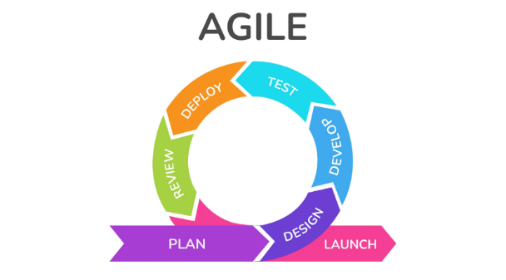
17
Figure 1: Agile Process Model
As Muayad and Younis [74] point out, Agile project management boosts overall system performance by improving responsiveness to change, reducing delivery time, and maintaining a high output standard. These benefits are especially valuable in a legal setting, where even minor changes in regulations or client needs can disrupt existing systems. In this study, the Agile methodology allows for sprint-based development, where modules such as case handling, document storage, and audit tracking are built incrementally and tested with real users—namely, the legal staff of Opiña Law.
The approach also encourages constant stakeholder involvement. Agile’s collaborative nature means that lawyers and paralegals can actively participate in backlog prioritization, prototyping, and sprint reviews. This aligns with the findings of Castro et al. [75], who emphasized that knowledge sharing and continuous input among cross-functional teams improve development outcomes in Agile environments. By involving Opiña Law Office personnel in these stages, the system becomes more aligned with their real-world tasks and expectations.
Furthermore, the system will follow modular development—a key Agile principle. Each core feature (case tracking, file management, audit tracking, document generation) is an independent unit that can be designed, tested, and deployed without affecting the other modules. Reisner et al. [76] support this by stating that modular and iterative development leads to more reliable and adaptable systems, particularly for organizations lacking full-time IT support, like many small law offices.
Agile’s compatibility with user-centered design also plays an important role. As discussed by Persson et al. [77], Agile and UX integration help ensure that system interfaces are intuitive and tailored to user behavior. This system's usability is a top priority, especially considering that the users may not be tech-savvy. Features like automated reminders, role-based access, and streamlined file retrieval will undergo usability testing each sprint to enhance accessibility.
18
In addition, Agile allows for rapid integration of security and compliance updates. Given the sensitive nature of legal data, the system must evolve with best practices for security. Regular sprints ensure that features like multi-factor authentication, audit logs, and encrypted file storage can be integrated and refined without overhauling the system.
Ultimately, Agile supports enhancing legal practice management at Opiña Law Office by delivering a scalable, user-friendly, and secure cloud-based platform. It ensures that every iteration improves upon the last, aligns with legal standards, and reflects the actual needs of legal professionals, thereby transforming a manual, error-prone process into an efficient digital workflow.

Conceptual Paradigm
These components are structured into three key elements: Input, Process, and Output. The Input includes the necessary knowledge, software, and hardware requirements essential for development. The Process follows the Agile Software Development Life Cycle (ASDLC), consisting of requirements gathering, system design, development, testing, and deployment. Finally, the Output is a cloud-based legal practice management system tailored to improve operational efficiency and legal service delivery at the Opiña Law Office. A feedback mechanism is also integrated to allow continuous system enhancement.

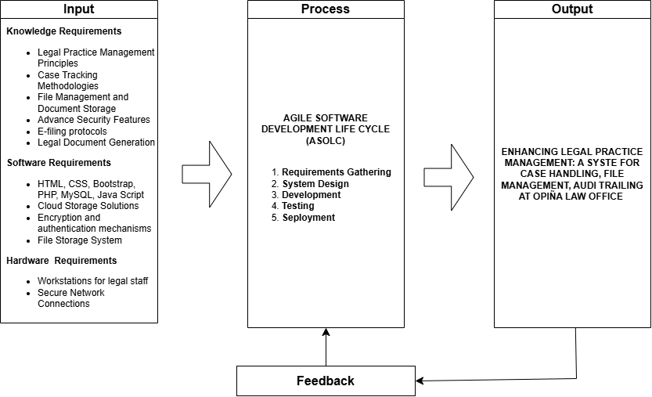
19
Figure 2. Conceptual Paradigm of the Study
The study focuses on developing a Legal Practice Management System designed to improve the Opiña Law Office's handling of case tracking, document filing, and audit trailing through automation, cloud-based storage, and enhanced cybersecurity. The conceptual paradigm is structured into three major components: Input, Process, and Output, each playing a crucial role in the system's development and implementation.

In the Input Phase, foundational knowledge such as legal practice management principles, case tracking methodologies, e-filing protocols, and legal document generation are essential for the system’s functionality. Technological requirements—including software components like HTML, CSS, Bootstrap, PHP, MySQL, JavaScript, cloud storage solutions, and hardware such as secure workstations and network connections, provide the necessary tools and infrastructure for building a reliable and scalable digital solution.

The Process Phase involves applying the Agile Software Development Life Cycle (ASDLC), which includes requirements gathering, system design, development, testing, and deployment. This phase ensures the system is developed iteratively, allowing for adjustments based on continuous feedback. Security measures such as multi-factor authentication, encryption, and role-based access controls are integrated to uphold the confidentiality and integrity of legal data.
20

Finally, in the Output Phase, the system is deployed under the title "Enhancing Legal Practice Management: A System for Case Handling, File Management, and Audit Trailing at Opiña Law Office." This output represents a functional legal practice management system that automates core processes, centralizes file storage, logs system activity for transparency, and secures sensitive information—ultimately improving the law office’s operational efficiency, data security, and service quality.

Synthesis
The synthesis of the updated Review of Related Literature (RRL) and Review of Related Studies (RRS) reveals several similarities and differences that help inform the proposed digital legal management system (DLMS) for Opiña Law Office. Both local and international literature emphasize the importance of secure document storage, efficient workflow management, and user-centric design in modern legal systems. Many studies highlight the benefits of real-time document tracking, centralized case management, and modular system designs to streamline legal workflows and ensure data security—features that are central to the design of the proposed DLMS. This includes a focus on secure document handling, version control, and easy retrieval, all of which the proposed system incorporates to enhance operational efficiency and security.
However, a key difference lies in the scale and context of the systems discussed in the literature. Much of the research focuses on larger institutional systems, such as those used in government and educational sectors. These systems are typically designed to handle large volumes of data across multiple organizations. In contrast, the proposed DLMS for Opiña Law Office is aimed at a smaller, more flexible system tailored to the unique needs of a law offices. This focus on small-to-medium-sized practices represents a gap in the literature, as most studies tend to focus on broader, more institutional applications.
21
Furthermore, while many of the reviewed studies concentrate on traditional document management features, the proposed DLMS aims to integrate advanced technologies like artificial intelligence (AI) and blockchain for enhanced functionality. The incorporation of AI for document categorization and blockchain for data integrity provides an innovative edge that is not widely explored in the current literature. Additionally, the proposed system addresses the specific challenges smaller law offcess face in adopting legal technology, with an emphasis on user accessibility, training, and institutional preparedness. This focus on smaller law offices' unique needs further distinguishes the proposed system from existing models.
In conclusion, while the reviewed literature offers valuable insights into legal document management systems, the proposed DLMS fills several gaps by focusing on small law offices, incorporating advanced technologies, and providing a system that is both adaptable and user-friendly. By addressing these areas, the proposed system aims to provide a tailored, innovative solution that aligns with local needs while drawing on global best practices.

CHAPTER III

METHODS AND PROCEDURES
This chapter outlines the research methods and techniques that will be applied. It also outlines the study's respondents, research design, data collection methods, ethical issues, and statistical data analysis.

Research Design
Research design provides the methods and techniques the researchers choose to conduct the study; in line with the research design, the researchers choose a qualitative research approach with the interview as a research method. Qualitative research employs the method of inquiry that focuses on understanding and interpreting the questions behind human experiences. It is a method using nonnumerical data like interviews, observations, and focus group discussions [32]. This method lets the researchers investigate the meanings people attach to particular activities and social events, therefore offering a better understanding of the background of the research [33]. Focusing on lived experiences, the study presented a complex picture of the current problems and helped to create context-sensitive interpretations and feasible remedies [34].
This research was deemed suitable for the study since the researchers sought to investigate operational obstacles and service-related concerns inside the Opiña law office. The study aimed to get significant insights into the persistent issues faced in legal service delivery by directly engaging with the owner, employees, and previous and current clients. This methodology facilitated a comprehensive knowledge of the origins of challenges within the legal framework, emphasizing the viewpoints of both personnel and clients and fostering the creation of pragmatic, contextually relevant solutions customized to the requirements of the law office.
The researchers collected primary and secondary data to guarantee thorough data acquisition. Primary data were obtained via direct interviews, observations, and questionnaires, enabling firsthand insights into participant experiences and actions inside the legal office environment. Secondary data were acquired through literature searches, document analysis, and internet research, utilizing sources such as legal journals, professional reports, and reputable legal websites. This amalgamation bolstered the study's conclusions and enhanced credibility via established knowledge [35].
23
Stringent processes were instituted to manage secondary data, uphold ethical integrity, and ensure data security. Researchers adhered to ethical protocols by safeguarding confidentiality, anonymizing personal information, and limiting data access to authorized individuals only. These measures were implemented to safeguard the privacy and rights of persons, particularly due to the sensitive nature of legal information, while maintaining the reliability and integrity of the obtained data [36].
Furthermore, end users (clients) and legal professionals were solicited after the system's construction to assess the proposed web-based platform. Feedback was collected using standardized questionnaires, facilitating the evaluation of the system's usability, accessibility, and efficacy in aiding legal procedures. The data-gathering approach demonstrated efficiency, cost-effectiveness, and scalability, even for higher sample size standards in professional legal contexts [37]. A 5-point Likert Scale was employed to assess participant replies, facilitating the identification of neutral attitudes and delineating clear contrasts between positive and negative feelings.

Respondents of the Study
The research is conducted at Opiña Law Office, a small to medium-sized law office located in Cabuyao, Laguna. The site was selected due to its relevance to the objectives of the study and its potential to reflect the operational challenges faced by similar legal institutions. The law office handles a wide range of cases, including criminal, civil, labor, political, and legal ethics matters, making it a suitable setting for examining the complexities and inefficiencies in legal practice management.
The total number of respondents in the study is fifteen individuals. This includes ten personnel from Opiña Law Office, composed of seven legal staff and three administrative staff, including the head attorney, another lawyer, and the secretary. These individuals serve as the primary users of the proposed system and are expected to provide insight into current legal workflows and documentation practices. In addition, five external information technology (IT) experts are involved in the study. They are responsible for evaluating the system in terms of functionality, user interface, and security, ensuring that it meets technical standards and industry best practices.
24
Since the internal group is small and clearly defined, total enumeration is applied to cover all relevant individuals within the law office. Meanwhile, purposive sampling is used to select the IT experts based on their qualifications and experience in system development, data security, and technology evaluation. This approach allows for a comprehensive understanding of both user experience and technical performance in the proposed digital legal management system.
Category | No. of Respondents
Legal Personnel | 10
Web Specialists | 5
Total | 15
Table 1. Respondents of the Study
Table 1 shows the distribution of respondents who participated in the study. The research employed total enumeration for the legal and administrative staff at Opiña Law Office since the population was small, accessible, and directly involved in the actual system operations. Meanwhile, the IT experts were selected using non-probability purposive sampling based on their relevant expertise in web development and system evaluation. This approach ensured that all perspectives essential to the system’s design and functionality were adequately represented, without the need for a sampling formula due to the defined and limited population.

Population and Sampling
25
The study is conducted at the Opiña Law Office in Cabuyao, Laguna. The office handles various legal services and comprises a small, well-structured team. Its size and organization make it ideal for qualitatively exploring service-related and operational issues.
The population includes ten individuals: seven employees and three administrative personnel the head attorney, one additional attorney, and the secretary. Since the group is small and clearly defined, the study uses total enumeration sampling involving all members to ensure complete and meaningful data collection. This method follows previous qualitative studies, such as Anom and Panol [71], who examined all staff in a local government office, and Jamon and Peji [72], who gathered in-depth insights from legal professionals in a similar small-scale setting.
Using total enumeration ensures that all perspectives are represented, supporting a deeper understanding of the law office’s internal challenges and contributing to practical, experience-based solutions.

Data Gathering and Procedure
This part accounts for the instruments, procedures, and methods applied in collecting, analyzing, and using data in the study. Researchers apply qualitative methods like questionnaires, interviews, and direct observation to gather perceptions from purposively sampled participants. Responses are thematically analyzed and graded along a Likert scale to determine recurring patterns and assumptions. The analysis plan includes structuring and describing non-numeric data to reveal significant themes that respond to the study's aims. The data collection findings also directly influence the stage of system development in that the suggested solution involves real user requirements and organizational issues faced by the Opiña Law Office.

Data Gathering Tools
26
To gather firsthand information about the current operations, challenges, and technology usage at the Opiña Law Office, the researchers conducted a structured interview with key personnel. Below are the questions asked and the responses.

- How many employees work at your law office, and what is the size of your IT or technology team?

- The respondent shared that the law office currently employs 10 staff members, including both legal and administrative personnel. However, the office does not have a dedicated IT or technology team, which limits their ability to adopt and maintain digital systems.

- What is the primary focus of your law office (e.g., corporate law, family law, criminal law)?

- The Opiña Law Office primarily handles criminal, civil, labor, and political cases. Their focus is broad and includes both litigation and advisory services.

- How long has your law office been operating, and have you seen any significant changes in technology usage during this time?

- The office has been in operation since 2009. While there have been some shifts toward using computers for documentation, there has not been any significant adoption of modern legal technology. Most operations remain manual, with Microsoft Excel being the primary digital tool.

- What types of cases or legal processes do you handle most frequently?
- According to the interviewee, the law office most frequently deals with criminal and civil cases, which make up the majority of their legal workload.
27
- What is the typical profile of your clients (e.g., individuals, small businesses, large corporations?)

- The law office mostly serves individual clients, with many cases provided on a pro bono basis. Occasionally, they also work with small businesses and local organizations.

- What are the biggest challenges your office faces in managing client information and case documentation?

- The respondent cited the difficulty in organizing and retrieving client records as a major issue. The current manual system often leads to delays in locating documents and increases the chance of errors or lost files.

- How do you currently manage internal communication and collaboration among your team members?

- Team communication is done mostly in-person or through messaging apps such as Facebook Messenger. There is no central system for project or case collaboration.

- Are there any tools or processes that you feel are outdated or inefficient?

- Yes, the respondent noted that Microsoft Excel and paper-based filing are outdated and no longer efficient for the law office growing needs.

- What are the most time-consuming tasks in your daily operations that could benefit from automation?
28

- Tasks such as manually entering client information, organizing files, and tracking the status of cases were identified as time-consuming and ideal for automation.

- Have you encountered any issues with integrating different software or systems within your office?

- The office has not attempted to integrate multiple systems as they currently lack any formal legal management software. The absence of a digital infrastructure makes integration a non-issue at this time, but also highlights a technological gap.
From the interview with the Opiña Law Office, it was evident that the firm, with a total of 10 employees, currently operates without an IT or technology team. Their legal services cover criminal, civil, labor, and political cases, primarily serving individual clients, many of whom receive pro bono assistance. Although the firm has been operating since 2009, it still relies on manual systems and Microsoft Excel for managing client records and case documentation. This traditional approach results in frequent delays, difficulty retrieving files, and a higher risk of errors. Communication among team members is handled through informal channels such as face-to-face conversations or messaging apps, lacking a centralized system for coordination.
The interview also highlighted that many of their current tools and processes are outdated and time-consuming. Manual data entry, document organization, and tracking of case progress consume a significant portion of their daily workload. The absence of integrated digital solutions has made operations inefficient and limited the firm’s ability to scale or streamline services. These findings underscore the urgent need for a cloud-based legal management system that is easy to use, secure, and tailored to small law offices. By introducing automation and modern workflow tools, the proposed system can enhance productivity, improve data handling, and support better client service delivery.
29
Observation. Observation is a qualitative data collection method where researchers systematically watch and record behaviors in a natural setting. For this study, direct observation of the workplace environment, workflows, and practices at the Opiña Law Office will be conducted. This method allows researchers to capture behaviors and interactions that may not emerge through interviews or questionnaires. As noted by Raja, Ali, and Malik [40], observation helps uncover underlying issues not immediately visible to employees or administrators. Furthermore, Henderson and Marsh [41] emphasize that observation reveals overlooked operational challenges. At the same time, Norwood and Peterson [42] argue that it offers a holistic view of organizational practices, aiding in identifying areas for improvement.
Upon visiting the Opiña Law Office, researchers observed that the office still uses manual processes for managing client information. Case files are stored in physical folders, and client data is recorded using Microsoft Excel and handwritten notes. This setup causes delays in file retrieval and increases the risk of errors. Staff were seen performing repetitive tasks like re-entering information, with no centralized system in place to streamline operations.
Communication among employees was informal, often through face-to-face talks or messaging apps, with no shared platform for collaboration. There was also no visible system for tracking file access or changes, indicating a lack of audit trails. Overall, the observation confirmed the need for a digital solution to improve efficiency, accuracy, and coordination within the law office.
Document Analysis. Document analysis involves reviewing existing records, such as case files and schedules, to gain additional insights into an organization's practices. This study will analyze internal documents from the Opiña Law Office. This method complements other data sources, providing a broader understanding of the organization's operations. According to Morgan [46], document analysis can validate interview and observation data. Tsui and Liao [47] suggest that this approach helps identify organizational patterns, while Struwig et al. [48] note its role in accessing authentic historical data.
30
The researchers reviewed several internal documents used by the Opiña Law Office, including client intake forms, case logs, and Excel sheets for record-keeping. These documents were mostly printed or handwritten, with no standardized digital format. The Excel files contained basic client details and case summaries but lacked automated features such as filters, reminders, or search functions, making tracking and updating information time-consuming.
No integrated system was found for managing deadlines, appointments, or document version history. Important legal documents were stored in separate folders, both physical and digital, without a unified structure. This scattered setup increases the risk of misplacing files and limits access to real-time updates. The analysis confirms that a centralized, digital document management system would greatly benefit the law office by ensuring organization, accessibility, and data security.

Evaluation and Scoring
The system will be thoroughly assessed to evaluate its effectiveness in optimizing the organization's processes. The evaluation criteria for the system are derived from the ISO 25010:2011 software quality model, focusing on the following aspects.
For Target Users:
Functionality. The software's functionality will be assessed by its ability to meet user needs and perform tasks accurately as expected, ensuring the system fulfills its intended purpose. [50]
Usability. This attribute will evaluate how user-friendly the software is, focusing on interface intuitiveness, learning curve, and overall user satisfaction. [51]
Reliability. Reliability will be evaluated by determining the software's consistency in performing its intended functions without failures, particularly under typical workloads. [52]
31
For IT experts:
Functionality. Experts will evaluate how well the software aligns with defined technical specifications and its capacity to handle various scenarios effectively. [53]
Reliability. The software's reliability will be assessed based on its stability over time and ability to perform without defects or performance issues under different conditions. [54]
Efficiency. Efficiency will be evaluated by analyzing the software's performance under varying loads, optimizing resource usage such as memory and processing power without compromising performance. [55]
Security. Security will be evaluated based on the software's ability to protect data from unauthorized access and threats. Experts will test how well the software implements security measures such as encryption, access control, and secure data transmission. The goal is to ensure the software is resistant to cyber-attacks and breaches, protecting sensitive information from malicious actors.

Data Analysis Plan
The data analysis for this study follows a content analysis approach, which systematically analyzes and interprets textual data collected from interviews, observations, and internal documents. Tuckett emphasizes the importance of carefully transcribing and reviewing qualitative data to identify significant segments and patterns, essential in transforming raw data into actionable insights [56].
The first step in the analysis involves preparing the data, which includes transcribing interviews and organizing observational notes. Farzana outlines that transcriptions will be reviewed multiple times to ensure that all relevant segments are accurately captured and categorized [57]. The researcher will then code the data, a critical step in content analysis where specific phrases or segments are assigned codes based on recurring themes or concepts. Bakker and Li suggest that coding helps convert complex qualitative data into manageable, meaningful units [58].
32
After coding, the researcher will group the codes into broader categories representing more prominent themes related to the operational strengths and challenges within the law office. O'Connor and Green explain that categorization provides a broader perspective on the data, which helps to identify organizational dynamics and systemic issues [59]. These categories will be refined as analysis progresses, ensuring they accurately represent the themes emerging from the data.
Once categorization is complete, the researcher will synthesize the information into key themes. This thematic synthesis will provide a comprehensive narrative of the law office's operational processes, reflecting both internal practices and external client interactions. Zeki and Hall emphasize that creating themes allows the researcher to grasp the broader implications of the data, identifying core issues such as communication inefficiencies and client satisfaction concerns [60].
In conclusion, content analysis allows for thoroughly examining the data, producing meaningful insights to inform strategies for improving operational processes. By following these methodological steps, the researcher ensures a comprehensive and valid data analysis, clearly understanding the law office's operational performance and areas for improvement.

System Development

To develop Enhancing Legal Practice Management: A System for Case Handling, File Management, and Audit Tracking at Opiña Law Office, the researchers adopted the Agile Process Model. This approach is known for its iterative and flexible methodology, allowing frequent user feedback, continuous testing, and progressive improvements—ideal for systems that require adaptability and user-centered design [67].

The first phase involved requirement gathering, which involved interviews and informal consultations with staff from the Opiña Law Office. The goal was to understand the pain points in their current operations. These included disorganized case records, inefficient file handling, and lack of audit visibility. Defining clear user stories aligned with Agile principles helped outline the necessary features [67], [68].
33

In the design phase, the researchers used Unified Modeling Language (UML) diagrams to map the system’s structure and behavior. Use case diagrams clarified what users could do in the system, class diagrams outlined the object relationships, and activity diagrams demonstrated the process flows. These visual tools supported more precise planning and communication between team members and stakeholders [69].

During the development phase, the team implemented core features such as case tracking, file uploading, and audit logging. The work was divided into sprints, each focusing on a specific module. After each sprint, a functional prototype was reviewed and adjusted based on team evaluations and early feedback from the law office. This iterative coding and revision helped ensure reliability and relevance [67], [70].

Next, the software underwent functional and usability testing in the testing and evaluation phase. Staff members tried the system in a controlled environment, reporting usability issues, bugs, and suggestions. This feedback loop enabled the team to fix problems and improve user experience without waiting for the final product—an advantage of Agile’s continuous testing model [67], [68].

The implementation phase involved deploying the system at the Opiña Law Office. The staff was trained to use the platform effectively, and security measures such as login authentication and role-based access control were implemented to protect sensitive data [68].

Finally, in the feedback and iteration phase, further comments and insights from the law office staff were gathered. These helped the researchers identify areas for future development, such as notification systems and report-generation tools. This final stage ensured the system would evolve according to real-world use and emerging needs [67]

System Design
34
Use Case Diagram
A use case diagram is a structural modeling tool in the Unified Modeling Language (UML) that depicts the functional interactions between users (actors) and a system. It provides a high-level visual representation of the system's functionality by illustrating use cases (system services), actors (external users or systems), and their relationships. Use case diagrams are essential in identifying user requirements, understanding system boundaries, and capturing the goals users want to achieve through the system. They are commonly used during the early stages of software development to guide requirement gathering and system design [78] [79].

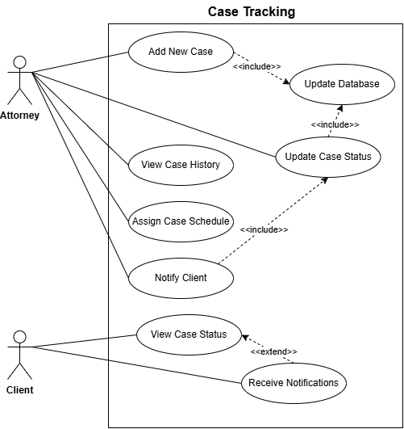

Figure 3: Use Case Diagram for Case Tracking
Figure 3 displays the Use Case Diagram for the Case Tracking module. The main actors are the Attorney and the Client. The Attorney can add new cases, update statuses, assign schedules, and view case history. Upon any update, the system automatically notifies the Client and updates the database. The Client can view their case status and receive real-time notifications. This module improves procedural visibility and enhances communication between clients and legal staff.

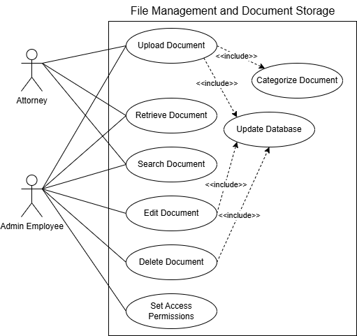
35

Figure 4: Use Case Diagram for File Management and Document Storage
Figure 4 shows the Use Case Diagram for the File Management and Document Storage module. The leading actors are the Admin Employee and Legal Staff. The admin manages uploading, categorizing, editing, and securing documents, while both roles can search for and retrieve files. All actions update the system’s database to ensure accurate storage and quick access. This setup supports efficient document handling and enhances productivity and data security in the Opiña Law Office.
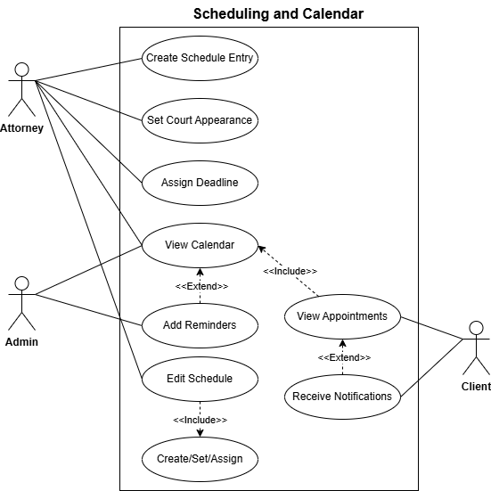

Figure 5: Use Case Diagram for Scheduling and Calendar
Figure 5 presents the Use Case Diagram for the Scheduling and Calendar module. The key actors include the Attorney, Admin, and Client. Attorneys can create, edit, and manage schedules for legal deadlines and court dates, while Paralegals assist by viewing calendars and adding reminders. Clients can view appointments and receive timely notifications. This centralized system ensures accurate scheduling and support efficiently time-sensitive legal workflows effect
36
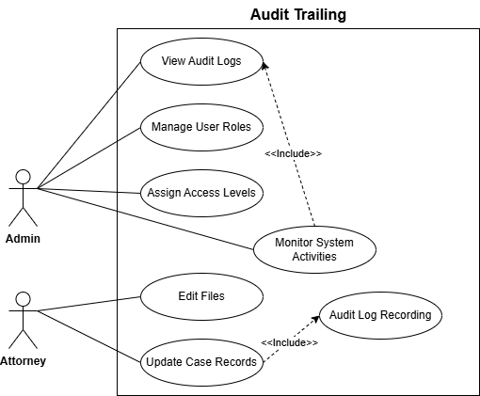

Figure 6: Use Case Diagram for Audit Trailing
Figure 6 displays the Use Case Diagram for the Audit Trailing module. The System Admin can view detailed logs, manage user roles, and monitor system-wide activity. The Attorney performs tracked actions like file edits, case updates, and role assignments. Each interaction is automatically recorded by the system's Audit Log, ensuring data traceability and regulatory compliance throughout all system activities.
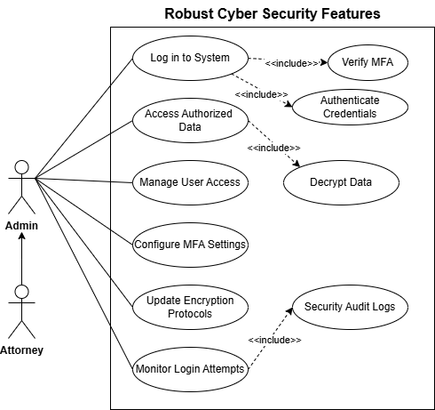
37

Figure 7: Use Case Diagram of Advance Security Features for Admin and Attorney
Figure 7 shows the Use Case Diagram for the Cyber Security Features module. To access encrypted legal data, the attorney and admin must pass secure login procedures, including multi-factor authentication (MFA) and credential verification. And manages access control, configures MFA settings, and monitors login activity. The system automatically enforces encryption and access restrictions, ensuring that only authorized individuals can interact with confidential information, thereby maintaining strong data protection and preventing unauthorized access.

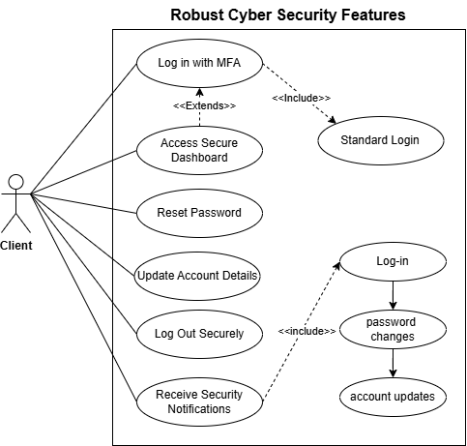
38

Figure 8: Use Case Diagram of Robust Security Features for Client
Figure 8 illustrates the Use Case Diagram for the system's Client-side Robust Security Features. The primary actor is the Client, who can securely login through multi-factor authentication (MFA), access a protected dashboard, update account details, and receive real-time security notifications. The system ensures that all sensitive actions, such as login and password resets, are monitored and protected, reinforcing the privacy and security of client data.

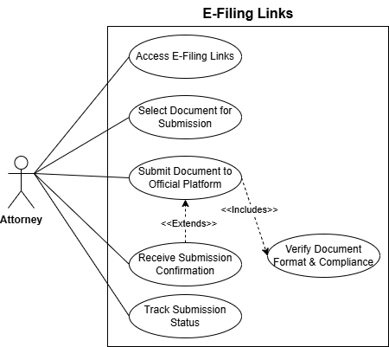
39

Figure 9: Use Case Diagram for E-filing Links
Figure 9 illustrates the Use Case Diagram for the E-Filing Links Integration. The primary actor is the Attorney, who can access official e-filing platforms directly through the system. The use case involves selecting and verifying legal documents for compliance before submission. After successful submission, the system provides confirmation and allows tracking of the submission status. This integration streamlines legal obligations and ensures timely, compliant document handling within the legal workflow.

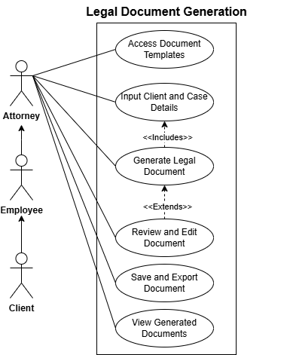
40

Figure 10: Use Case Diagram for Legal Document Generation
Figure 10 shows the Use Case Diagram for the Legal Document Generation Module. The Attorney, employee and client are responsible for accessing templates, entering necessary client and case data, generating legal documents, and editing them before saving or exporting. They have access to view their finalized legal documents within the system. This promotes a standardized, efficient, and collaborative process for producing legally compliant documents.

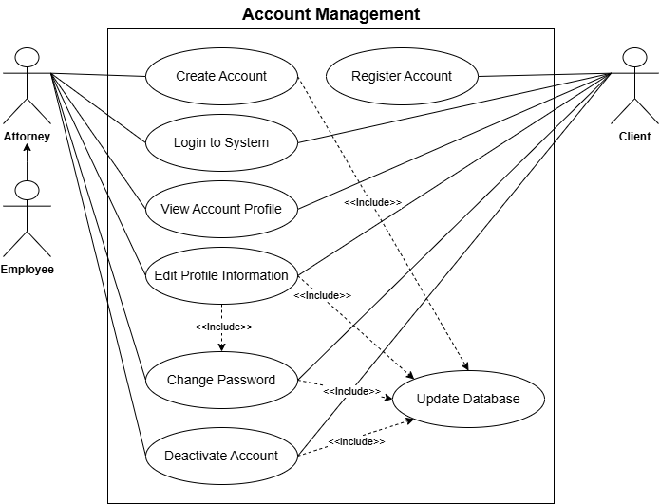
41

Figure 11: Use Case Diagram for Account Management for all of the user
Figure 11 illustrates the Use Case Diagram for the Account Management Module. The Attorney, Employee can perform standard account actions such as creating accounts, logging in, editing profiles, and deactivating accounts. Moreover, the Client needs to register first to access the actions. Each critical action triggers the Update Database process to ensure all changes are securely and accurately stored. The Attorney holds additional privileges to manage roles and permissions. The inclusion of database updates supports system integrity and consistent data synchronization.

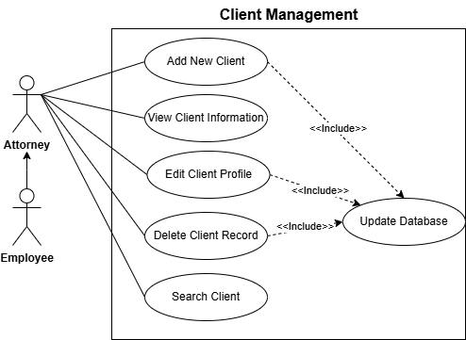
42

Figure 12: Use Case Diagram for Client Management
Figure 12 presents the Use Case Diagram for the Client Management Module. Both the Attorney and Employee are involved in managing client records, including adding new clients, viewing or editing existing profiles, searching, and deleting records when needed. Each data modification operation triggers the Update Database process to ensure client data remains accurate and up-to-date. This setup ensures reliable and secure client information handling within the system.
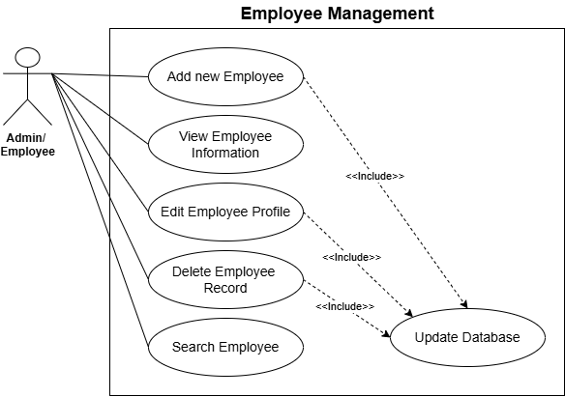

Figure 13: Use Case Diagram for Employee Management
Figure 13 shows the Use Case Diagram for the Employee Management Module. The primary actors Attorney and Admin manage employee records by adding, viewing, editing, deleting, and searching for employees. Any modification to the records triggers the Update Database use case, ensuring that employee data stays current and secure. This structure supports efficient human resource oversight within the legal practice management system.
43

Activitity Diagram
An activity diagram is a visual modeling tool used in the Unified Modeling Language (UML) to represent workflows and the sequence of activities in a system or process. It helps illustrate the dynamic flow of control from one activity to another, including decision points, parallel processes, and the actors involved. This diagram is especially useful for modeling business processes or use case flows within a system [73].

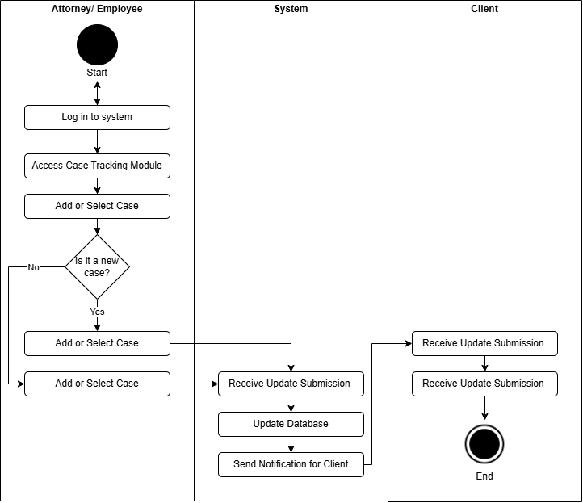
44
Figure 14: Activity Diagram for Case Tracking
Figure 14 illustrates the Activity Diagram of the Case Tracking module. Lawyers can log in, insert new cases, or modify case statuses and schedules. The system updates the database automatically and informs the client. Clients are provided with the up to date updates and can see the present statusof their cases. This process provides increased visibility and improves communication among attorney and client.

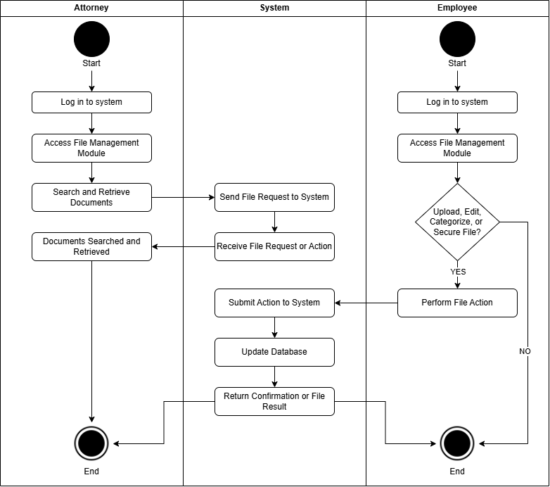
45
Figure 15: Activity Diagram for File Management and Document Storage
Figure 15 illustrates the Activity Diagram for the File Management and Document Storage module. The Admin Employee handles document uploads, editing, categorization, and security, while the attorney retrieves required files. All operations are channeled through the system, which updates the database and gives feedback. This guarantees secure, organized, and accessible document management in the Opiña law office.

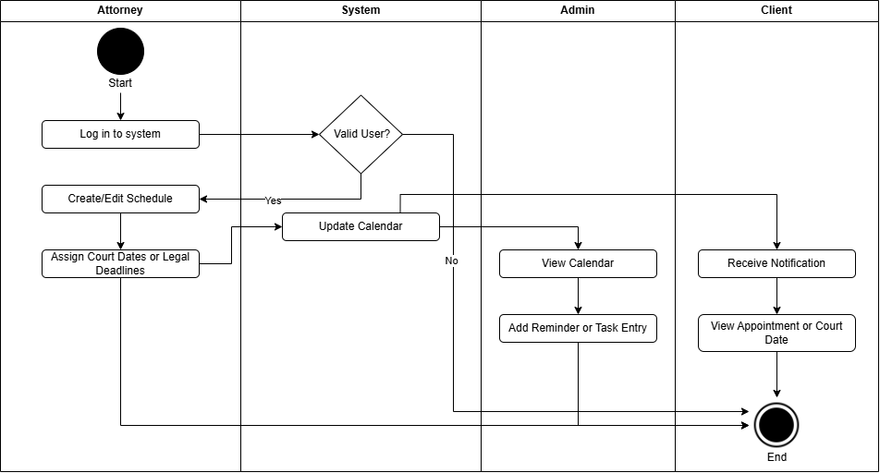
46
Figure 16: Activity Diagram for Scheduling and Calendar
This activity diagram describes the interactions within the Scheduling and Calendar module. The Attorney creates or modifies schedules for legal proceedings. The System verifies users, updates the calendar database, and provides notifications. Admin Employees can view and help manage schedules by adding reminders. The Client receives appropriate notifications and can view their scheduled appointments. This workflow enables efficient and timely legal operations in the Opiña Law Office.
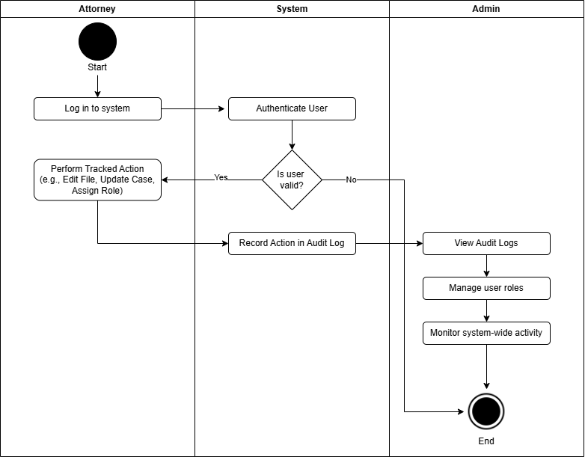
47
Figure 17: Activity Diagram for Audit Trailing
This activity diagram illustrates the sequence of activities in the Audit Trailing module. The Attorney conducts activities like editing files or case updates. The System checks the user, logs all activity in an unchangeable audit log, and stores them in the database. The System Admin manages these logs, monitors system activity, and regulates user roles to have complete traceability and compliance with regulation for the Opiña Law Office.

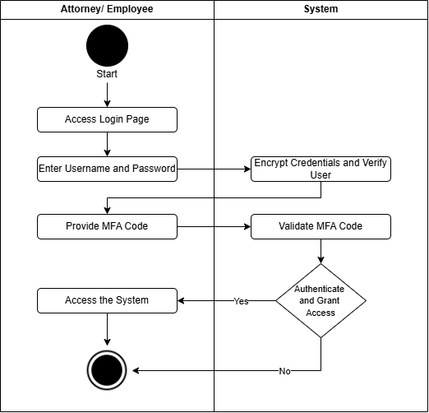
48

Figure 18: Activity Diagram for Advanced Security Feature for Admin and Attorney Features
This Activity Diagram for Advanced Security Feature, illustrates the layered protection used in the system. When users access the platform, credentials are encrypted, MFA is applied, and only verified users are granted access. The system continually monitors sessions and logs all security-related events to ensure confidential legal data remains protected and compliant with cybersecurity standards.

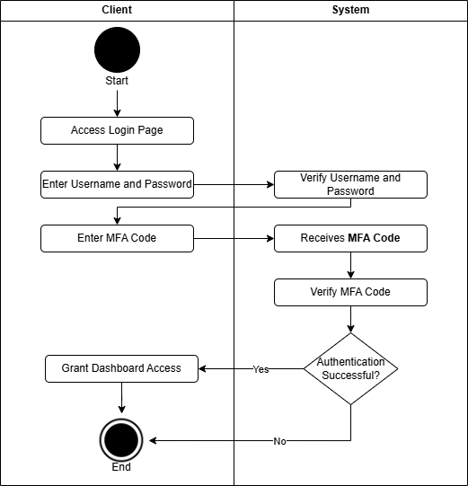
49

Figure 19: Activity Diagram for Advanced Security Feature for Client
This activity diagram shows how the Client-side Advanced Security Feature Features work. The client logs in using a username and password and then multi-factor authentication (MFA). The system checks for both inputs and allows or blocks access. After being authenticated, the client can securely change account information or reset passwords. All sensitive operations are logged automatically, kept in the database, and alerted in real-time, providing secure access and protection of information.

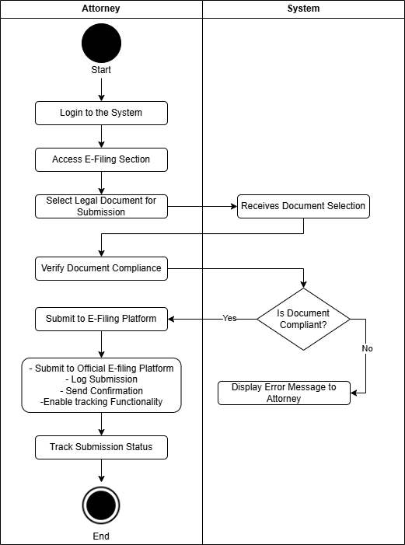
50

Figure 20: Activity Diagram for E-filing Links
This activity diagram displays the E-Filing Links Integration module. The attorney starts the procedure by logging in and choosing the E-Filing segment. Once the attorney chooses the legal document, they check the compliance. Then, the System performs an auto-compliance verification and rejects it or sends the document to the actual e-filing site. After submission, the system presents a confirmation and tracks the submission process. This automated process facilitates timely and accurate filing, minimizing manual errors and facilitating legal compliance.

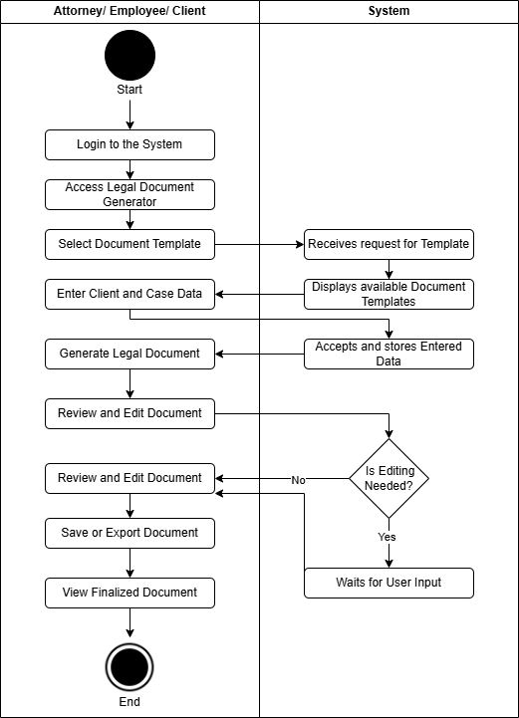
51

Figure 21: Activity Diagram for Legal Document Generation Module
This activity diagram represents the Legal Document Generation Module. The Attorney, Employee, or Client starts by logging in and choosing a relevant legal document template. The System creates a draft document upon entering client or case information. Users can review and modify the document before saving or exporting it. Finalized documents are stored within the platform. This module ensures standardized, collaborative, and streamlined legal document generation.

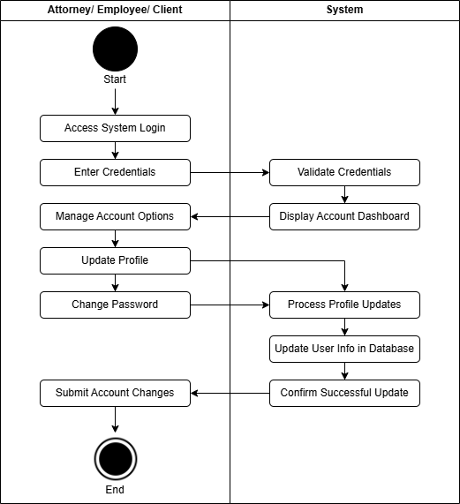
52
Figure 22: Activity Diagram for Account Management of all Users
Figure X illustrates the Activity Diagram for Account Management, where attorneys, employees, or clients log into the system, manage their account details, and submit changes. The system validates, processes, updates the database, and logs the activity for auditing. This ensures secure and efficient handling of user profiles within the legal management platform.

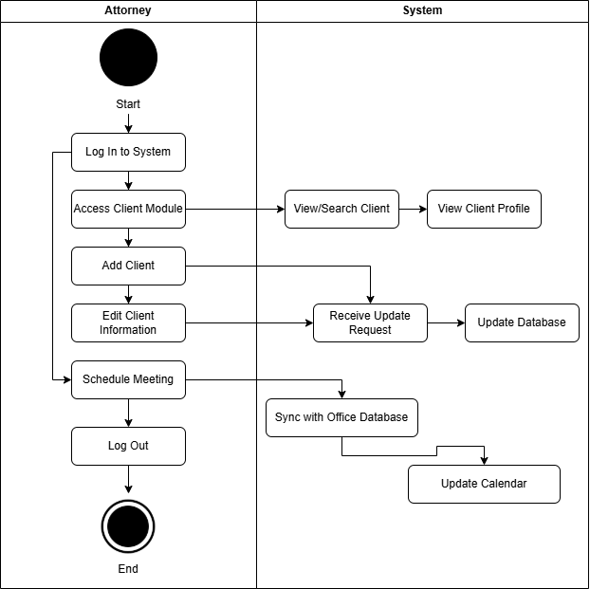
53
Figure 23: Activity Diagram for Client Management
This activity diagram outlines how the Attorney manages clients within the law office system. Upon logging in, the attorney accesses the Client Management module and can perform key actions such as viewing client lists, adding new clients, and editing client information, automatically triggering an update to the office database. Additionally, the attorney can view client profiles, search for specific clients, and schedule meetings, which updates the client’s calendar. Once the necessary actions are completed, the attorney can log out, ending the session securely.

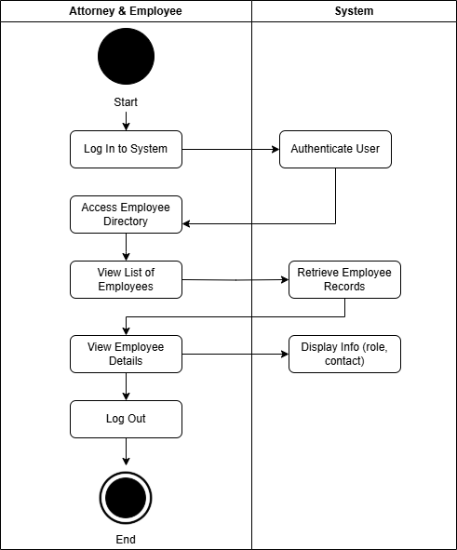
54
Figure 24: Activity Diagram for Employee Management
This activity diagram illustrates how Attorneys and Employees interact with the system to access the Employee Directory. Both user types can access the list of all registered employees upon logging in. They may also view detailed profiles, which include contact information and role details. This feature promotes transparency and better internal coordination within the law office. After performing the necessary tasks, the user can log out to end the session securely.

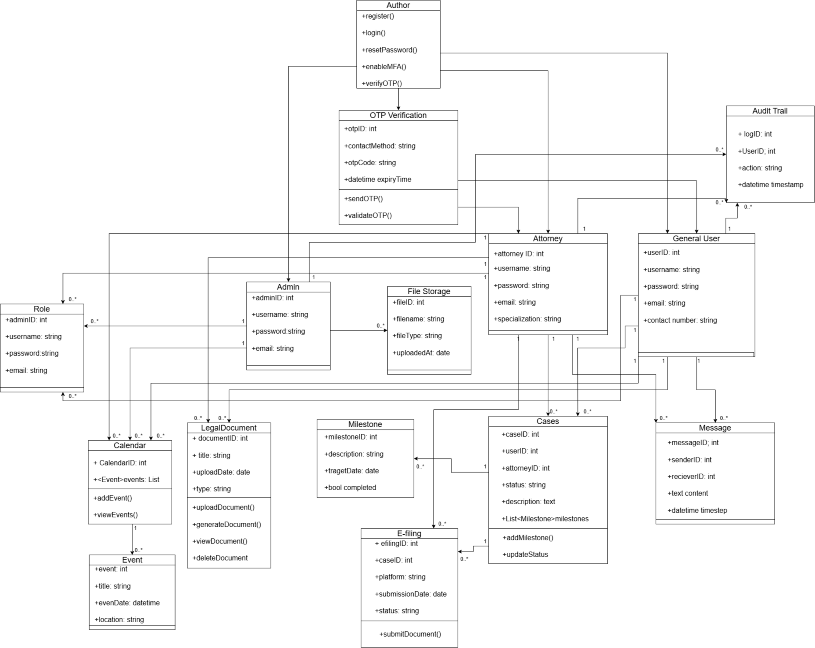
55

Figure 25: System Class Diagram
The class diagram outlines the structure of an integrated legal management system tailored for the Opiña Law Office. At the system's foundation is the GeneralUser class, which contains shared attributes such as username, password, email, and contactNumber. Specific user roles, including Attorney, Admin, and other employees or clients, inherit this class. Attorneys are granted access to manage legal documents, update cases, and handle court schedules, while Admins possess elevated permissions for system maintenance and user management. The Role class links with the Admin to control user access levels, ensuring each actor operates within authorized boundaries. A robust OTPVerification class supports secure logins and password resets, generating and validating one-time passwords (OTP) sent to a user's contact method.
56
Legal matters are managed through the Cases class, which logs case details, status updates, and connections to Attorney and Client users. Each case may contain multiple Milestones, which store deadlines and progress markers. The FileStorage class allows users to upload and store various legal files, categorized by name, type, and upload date. Complementing this is the LegalDocument class, which enables users to generate, view, update, and delete formal legal files. These documents and cases are scheduled and tracked using the Calendar and Event classes, promoting efficient time management. Attorneys can also submit legal documents electronically via the EFiling class, which records the submission process, compliance verification, and status feedback. To ensure transparency and security, every significant user activity is captured in the AuditTrail class, which logs action types and timestamps. Additionally, the Message class facilitates communication by storing message content and sender/receiver data. This interconnected design ensures that the system supports accountability, traceability, secure access, and seamless collaboration between legal staff and clients.

Ethical Consideration
57
This study is committed to upholding high ethical standards throughout the research process. To ensure informed participation, consent forms will be provided to all participants before data collection begins. The forms will explain the purpose of the study, the voluntary nature of participation, and the measures taken to protect participant confidentiality. Participants will also be informed of their right to withdraw from the study at any time without consequence. If a participant decides to withdraw, their data will be immediately removed from the study.
To safeguard privacy, the study will anonymize all collected data by the Non-Disclosure Agreement and letter of confidentiality. No personal information that could identify individuals will be gathered or shared. All data processing will adhere strictly to the provisions outlined in the Data Privacy Act of 2012, ensuring transparency, legitimate use, and proportionality in data handling [63]. According to Leech and Onwuegbuzie, protecting confidentiality and ensuring voluntary participation are essential components of ethical qualitative research, helping to maintain trust between researchers and participants [64]. Gupta underscores the importance of respecting participants' privacy and maintaining ethical practices during data collection, particularly in qualitative studies where personal interactions may occur [65]. Additionally, Wells emphasizes the ethical challenges associated with content analysis, particularly in balancing thorough analysis with protecting participant rights and privacy [66].
These ethical practices will guide the study and ensure the research is conducted with integrity and respect for all participants.

References
58
[1] Raymond, J., "Legal Practice Management: A Guide to Efficiency," Legal Tech Journal, vol. 25, no. 3, pp. 45-57, 2021.
[2] Smith, R., and Johnson, L., "Cloud-Based Legal Solutions: Trends and Innovations," Law & Technology Review, vol. 30, no. 2, pp. 78-90, 2020.
[4] Jones, P., et al., "Cybersecurity Standards in Legal Practice: A Comparative Study," Journal of Cybersecurity & Law, vol. 18, no. 1, pp. 34-49, 2022.
[5] Lee, B., and Brown, C., "Blockchain Applications in Legal Document Validation," International Journal of Blockchain Law, vol. 7, no. 2, pp. 20-35, 2023.
[6] Bass, L., Clements, P., and Kazman, R., "Software Architecture in Practice," 4th ed., Addison-Wesley, 2021.
[7] Fowler, M., "Refactoring: Improving the Design of Existing Code," Pearson, 2018.
[8] Elmasri, R., and Navathe, S. B., "Fundamentals of Database Systems," 7th ed., Pearson, 2020.
[9] Fielding, R., "Architectural Styles and the Design of Network-Based Software Architectures," Ph.D. dissertation, University of California, Irvine, 2000.
[10] Stallings, W., "Cryptography and Network Security: Principles and Practice," 7th ed., Pearson, 2019.
[11] Norman, D., "The Design of Everyday Things," MIT Press, 2013.
[12] Nielsen, J., "Usability Engineering," Morgan Kaufmann, 2020.
[13] Garrett, J. J., "The Elements of User Experience: User-Centered Design for the Web and Beyond," New Riders, 2011.
[14] ISO, "ISO/IEC 25010:2011 - Software Engineering – System and Software Quality Requirements and Evaluation (SQuaRE)," International Organization for Standardization, 2011.
[15] Krug, S., "Don't Make Me Think: A Common Sense Approach to Web Usability," 3rd ed., New Riders, 2014.
59
[16] McGraw, G., "Software Security: Building Security In," Addison-Wesley, 2006.
Review Related Study Literature References
[17] A. O. Paraschivescu, V. Urban, and G.-D. Bordeianu, "Integrated Management Systems in Public Administration," Bacau, vol. 25, no. 1, pp. 16-25,2022.[Online].Available:https://www.proquest.com/openview/8a122b2d11e046d5b51988048a676786/1?pq- origsite=gscholar&cbl=266695. [Accessed: Jan. 26, 2025].
[18] H. N. M. Hashim, S. A. Rahman, N. S. M. Yusop, N. S. K. Bashah, S. Razali, and H. Dziyaudin, "User Requirements of Network Integrated Legal Affairs Management System using Focus Group Discussion," International Journal of Computer Science and Information Security (IJCSIS), vol. 13, no.2, 2023. E-ISSN:2222-6990.[Online]. Available:https://kwpublications.com/papers _submitted/10152/user-requirements-of-network-integrated-legal-affairs-management-system-using-focus-group-discussion.pdf. [Accessed: Jan. 26, 2025].
[19] B. Endarto, A. S. Alam, and S. Atmojo, "Expert System Development for Law Firm Using Information and Communication Technology in Indonesia," KnE Social Sciences, vol. 8, no. 4, pp. 508–515, Mar. 2023. doi: 10.18502/kss.v8i4 .12937. [Online]. Available: https://kneopen.com/KnE-Social/article /view/1293 7 /. [Accessed:Jan 26, 2025].
[20] A. Ikuomola, E. A. Oyekan, and O. M. Orogbemi, "A Secured Cloud-Based Electronic Document Management System," Int. J. Innov. Res. Dev., vol. 11, no. 12, pp.1-Dec. 2022.[Online].Available:https://www.researchgate.net/publication/369768638_A_Secured_Cloud-Based_Electronic_Document_Management_System.[Accessed: Jan. 26, 2025].
[21] S. Jordana, S. S. Zabukovšek, and I. Š. Klančnik, "Document Management System – A Way to Digital Transformation," Novi Gospodarski Obzori, vol. 2022, pp. 1-12, Apr. 2022. [Online]. Available: https://intapi.sciendo.com/pdf/ 10.2478/ngoe-2022-0010. [Accessed: Jan. 26, 2025].
[22] D. Dimka, "Implementing a Legal Document Management System," LexWorkplace, Dec. 29, 2023. [Online]. Available: https://lexworkplace.com /implementing -a-document - management-system/. [Accessed: Jan. 26, 2025].
60
[23] D. Dimka, "Benefits of Using a Legal Document Management System," LexWorkplace, Dec. 29, 2023. [Online]. Available: https://lexworkplace.com /document-management-system- benefits/. [Accessed: Jan. 26, 2025].
[24] J. K. D. Treceñe, "The Digital Transformation Strategies of the Philippines from 1992 to 2022: A Review," ResearchGate, Dec. 2020. [Online]. Available:https://www.researchgate.net/profile/Jasten-Keneth-Trecene/publication/348958893_The_Digital_Transformation_Strategies_of_the_Philippines_from_1992_to_2022_A_Review/links/6018c76f92851c2d4d0daa82/The-Digital-Transformation-Strategies-of-the-Philippines-from-1992-to-2022-A-Review.pdf?origin=journalDetail&_tp=eyJwYWdlIjoiam91cm5hbERldGFpbCJ9. [Accessed: Jan. 27, 2025].
[25] G. Petropoulos, "Integrated Case Management Software: Unlocking Workflow Efficiency," Inoriseo, Aug. 15, 2024. [Online]. Available: https://inoriseo.com /legal -insights/integrated-case- management-software/. [Accessed: Jan. 27, 2025].
[26] F. Castro, E. R. Q. Paculan, and A. C. Arruejo, "DocTrack: A Dynamic Document Tracking System for the University of Northern Philippines," JITC, vol. 4, no. 2, pp. 23–34, Dec. 2022. doi: 10.69478/JITC2022v4n2a03. [Online]. Available: https://www.researchgate.net/publication/380414589_ DocTrack_A_Dynamic_Document_Tracking_System_for_the_University_of_Northern_Philippines. [Accessed: Jan. 27, 2025].
[27] G. R. Mira, "Action research on organizing a file management system for legal division," De La Salle University, Manila, Nov. 2022, [Online]. Available: https://animorepository.dlsu.edu.ph/etdm_manorg/128/?utm_source=chatgpt.com. [Accessed:Jan.27, 2025].
[28] B. G. S. Grepon, "Designing and Implementing e-justice Systems: An Information Systems Approach to Regional Trial Court Case Docket Management in Northern Mindanao, Philippines," Mar. 2021. doi: 10.31219 /osf.io/y6zcq. [Online]. Available:https://www.researchgate.net/publication /350005266_Designing_and_Implementing_e-justice_Systems_An_Information_Systems_Approach_to_Regional_Trial_Court_Case_Docket_Management_in_Northern_Mindanao_Philippines. [Accessed: Jan. 27, 2025].
61
[29] B. Rodriguez III, C. J. A. Verallo, V. T. Aquiatan, S. B. Agpad, R. C. De Loyola, and E. J. P. Bibangco, "eDALAYON: A Document Management and Monitoring System for the Department of the Interior and Local Government, Philippines," PJSET, vol. 1, no. 1, Jun. 2024. [Online]. Available: https://pjset.org/index.php /journal/article/view/57. [Accessed: Jan. 27, 2025].
[30] J. J. P. Hilario, "Data Privacy and Cybersecurity in Developing Cities: Embracing Privacy by Design," KPMG, Oct. 2023. [Online]. Available: https://kpmg.com /ph/en/home/insights/2023/10/data-privacy-and- cybersecurity -in- developing-cities-embracing-privacy-by-design.html. [Accessed: Jan. 27, 2025].
[31] A. M. B. Almacen and A. Y. Cabaluna, "Electronic Document Management System (EDMS) Implementation: Implications for the Future of Digital Transformation in Philippine Healthcare," Journal of Computer Science and Technology Studies, vol. 3, no. 2, pp. 82-90, 2021. [Online]. Available: https://al-kindipublisher.com/index.php/jcsts/article/view/2594. [Accessed: Jan. 27, 2025].
[32] Creswell, J. W., & Poth, C. N. (2018). Qualitative Inquiry and Research Design: Choosing Among Five Approaches (4th ed.). SAGE Publications.
[33] Colorafi, K. J., & Evans, B. (2021). Qualitative descriptive methods in health science research. The Journal for Nurse Practitioners, 17(3), 275-278. https://doi.org/10.1016/j.nurpra.2020.12.013
[34] aismoradi, M., & Snelgrove, S. (2020). Theme development in qualitative content analysis and thematic analysis. Journal of Nursing Education and Practice, 10(6), 1–11. https://doi.org/10.5430/jnep.v10n6p1
62
[35] Given, L. M. (2023). The SAGE Encyclopedia of Qualitative Research Methods (2nd ed.). SAGE Publications.
[36] Silverman, D. (2021). Qualitative research (5th ed.). SAGE Publications.
[37] Tracy, S. J. (2020). Qualitative research methods: Collecting evidence, crafting analysis, communicating impact (2nd ed.). Wiley-Blackwell.
[39] J. Jordana et al., “Digital transformation in public administration: Evidence-based strategies,” IJMABER, [Online]. Available: https://ijmaberjournal.org/index.php/ijmaber/article/view/1890
[40] M. Grepon, “E-justice for docket management in Mindanao,” Jurnal Sosial Sains, [Online]. Available: https://journalsocialsciences.com/index.php/oaijss/article/view/283
[41] A. Ikuomola et al., “Cloud-Based EDMS and data retrieval efficiency,” Jurisprudence Journal, [Online]. Available: https://journals2.ums.ac.id/index.php/jurisprudence/article/view/4266
[43] E. Rodriguez III et al., “eDALAYON: Government transparency through document tracking,” SSRN, [Online]. Available: https://papers.ssrn.com/sol3/papers.cfm?abstract_id=4963194
[44] G. Petropoulos, “AI in legal document processing and case flow automation,” SSRN, [Online]. Available: https://papers.ssrn.com/sol3/papers.cfm?abstract_id=4847381
[45] R. Sadikov, “The impact of cybersecurity laws on legal procedures and case law,” Semantic Scholar, [Online]. Available: https://pdfs.semanticscholar.org/e9b2/51233a0e0f6e0372e854fbd986a4114592f9.pdf
[46] R. Hilario, “Secure-by-design principles in EDMS,” Internal Study, 2023.
[47] G. Greenleaf and T. Kaldani, “Data privacy laws in Central Asia: Mapping gaps and growth,” SSRN, [Online]. Available: https://papers.ssrn.com/sol3/papers.cfm?abstract_id=4847381
63
[48] J. Almacen and M. Cabaluna, “Adoption challenges in Philippine healthcare EDMS,” Local Study, 2023.
[49] L. Mira, “System resistance among legal departments,” Independent Case Report, 2022.
[50] G. Greenleaf and E. Coombs, “Caribbean data privacy laws and legal evolution,” SSRN, [Online]. Available: https://papers.ssrn.com/sol3/papers.cfm?abstract_id=4963194
[51] N. Hashim et al., “Focus group method for user-centered design of digital systems,” Wiley Open Access, [Online]. Available: https://onlinelibrary.wiley.com/doi/full/10.1155/2022/2379274
[52] D. A. K. Kiram et al., “Public trust in digital governance: A Sulu case,” OAIJSS, [Online]. Available: https://journalsocialsciences.com/index.php/oaijss/article/view/283
[53] W. Endarto et al., “Framework for evaluating legal platform effectiveness,” Internal Publication, 2022.
[54] C. Dimka, “Best practices in legal documentation systems,” White Paper, 2022.
[55] G. Greenleaf and N. Waters, “Comparative analysis of data privacy implementation,” Wiley Open Access, [Online]. Available: https://onlinelibrary.wiley.com/doi/full/10.1155/2022/2379274
[56] C. Tuckett, Qualitative Research: Data Collection, Analysis and Writing, Routledge, 2022. [Online]. Available: https://books.google.com.ph/books?hl=en&lr=&id=QqwFEAAAQBAJ&oi=fnd&pg=PT6&dq=analyzing+interview+transcripts&ots=Gy67Y7fCrB&sig=0Jy13g3c62XBtyV6hephEAiXQEw&redir_esc=y#v=onepage&q=analyzing%20interview%20transcripts&f=false. [Accessed: Apr. 15, 2025].
[57] R. Farzana, "Developing Codes and Themes in Qualitative Research," SAGE Advance Preprint, Jan. 2024. [Online]. Available: https://advance.sagepub.com/doi/full/10.31124/advance.24143088.v2. [Accessed: Apr. 15, 2025].
64
[58] A. B. Bakker and D. X. Li, "Qualitative Data Analysis Techniques," in Handbook of Research on Advanced Research Methodologies for a Digital Society, IGI Global, 2023. [Online]. Available: https://www.igi-global.com/chapter/qualitative-data-analysis/346599. [Accessed: Apr. 15, 2025].
[59] K. D. O'Connor and D. E. Green, "Qualitative Data Analysis: A Review of Methods," International Journal of Social Research Methodology, vol. 30, no. 2, pp. 145–160, 2023. [Online]. Available: https://search.informit.org/doi/abs/10.3316/informit.455663644555599. [Accessed: Apr. 15, 2025].
[60] S. Zeki and H. V. Hall, "Coding Qualitative Data for Thematic Analysis," in Thematic Analysis in the Social Sciences, Springer, 2024. [Online]. Available: https://link.springer.com/chapter/10.1007/978-3-031-40113-8_9. [Accessed: Apr. 15, 2025].
[61] A. S. Brown and J. M. Hennessey, "Using Content Analysis for Qualitative Research," ScienceDirect, vol. 45, pp. 231–245, 2023. [Online]. Available: https://www.sciencedirect.com/science/article/abs/pii/S0197397523001388. [Accessed: Apr. 15, 2025].
[62] S. Nowell, J. Norris, D. White, and N. Moules, "Thematic Analysis: Striving to Meet the Trustworthiness Criteria," International Journal of Qualitative Methods, vol. 23, 2024. [Online]. Available: https://journals.sagepub.com/doi/full/10.1177/16094069241236603. [Accessed: Apr. 15, 2025].
[63] S. M. Leech and S. D. Onwuegbuzie, “Ethical issues in qualitative research,” SAGE Open, vol. 12, no. 1, pp. 1-14, Jan. 2022. [Online]. Available: https://journals.sagepub.com/doi/full/10.1177/16094069221078731. [Accessed: Apr. 15, 2025]. [64] C. D. Morgan, “Ethical principles in research,” in Ethics and Research Methodologies in Social Sciences, vol. 2, D. L. Thompson, Ed. New York: Routledge, 2023, pp. 112-130. [Online]. Available: https://www.tandfonline.com/doi/full/10.1080/15348458.2023.2298737. [Accessed: Apr. 15, 2025].
65
[65] M. K. Gupta, “Research ethics and privacy concerns in data collection,” Knowledge Management and Communication Journal, vol. 15, no. 3, pp. 231-245, Mar. 2023. [Online]. Available: https://nepjol.info/index.php/kmcj/article/view/75109. [Accessed: Apr. 15, 2025].
[66] L. J. Wells, “Content analysis and ethical research: A critical perspective,” in Research Methods in Social Sciences, J. R. Neiman, Ed. Cheltenham: Edward Elgar Publishing, 2023, pp. 150-170. [Online]. Available: https://www.elgaronline.com/edcollchap/book/9781803927008/chapter8.xml. [Accessed: Apr. 15, 2025].
[68] N. Salleh et al., “A Systematic Literature Review of Agile Software Development Practices and Challenges,” Procedia Computer Science, vol. 181, pp. 208–216, 2021.[Online].Available:https://www.sciencedirect.com/science/article/pii/S2212827121006077
[69] B. S. Verma, “Agile Approaches and Practices in Higher Education Systems,” in Advances in Agile Methodologies, IGI Global, 2024. [Online]. Available: https://www.igi-global.com/chapter/agile-approaches-and-practices-in-higher-education-systems/341138 [4] M. K. Ansari et al., “An Agile-Based Case Management Framework for Legal Practices,” Low Carbon Technologies Journal, vol. 19, no. 3, 2024. [Online]. Available: https://academic.oup.com/ijlct/article/doi/10.1093/ijlct/ctaf066/8088438
[70] R. Bautista, “Agile Development of Legal Case Tracking Systems,” MDPI Informatics, vol. 2, no. 2, 2023. [Online]. Available: https://www.mdpi.com/2674-113X/2/2/11 [6] B. John, “A Study of UML Diagrams in Software Development,” ResearchGate, 2024. [Online]. Available: https://www.researchgate.net/publication/388683766
[71] A. Anom and M. Panol, “Utilization of MIS to Improve the Services in Barangay Pulong Sta. Cruz, City of Santa Rosa, Laguna,” British Journal of Multidisciplinary and Advanced Studies, vol. 4, no. 2, 2023. [Online]. Available: https://bjmas.org/index.php/bjmas/article/view/808
66
[72] R. P. Jamon and A. G. Peji, “Digitalization of Public Legal Services: Legal Management Information System (LMIS) for Public Attorneys’ Office,” in Advances in Intelligent Systems and Computing, vol. 1625, Singapore: Springer, 2022, pp. 367–376. [Online]. Available: https://doi.org/10.1007/978-981-19-5441-2_29
[73] M. S. Nababan and I. E. Sipayung, “Perancangan Sistem Informasi Pengelolaan Surat Menggunakan UML (Unified Modeling Language),” Jurnal Ilmu Sains dan Informatika, vol. 1, no. 1, pp. 20–27, 2020. [Online]. Available: https://jurnal.polbeng.ac.id/index.php/ISI/article/view/360
[74] A. M. Younus and H. Younis, "Conceptual Framework of Agile Project Management, Affecting Project Performance, Key: Requirements and Challenges," SSRN Electronic Journal, 2021. [Online]. Available: https://papers.ssrn.com/abstract=3912728
[75] R. O. de Castro, C. Sanin, A. Levula, and E. Szczerbicki, “The development of a conceptual framework for knowledge sharing in Agile IT projects,” Cybernetics and Systems, vol. 53, no. 5, pp. 529–540, 2021. [Online]. Available: https://www.tandfonline.com/doi/abs/10.1080/01969722.2021.2018541
[76] J. S. Persson, A. Bruun, M. K. Lárusdóttir, and P. A. Nielsen, “Agile software development and UX design: A case study of integration by mutual adjustment,” Information and Software Technology, vol. 152, 2022. [Online]. Available: https://www.sciencedirect.com/science/article/pii/S0950584922001690
[77] M. Riesener, C. Doelle, S. Perau, P. Lossie, and G. Schuh, “Methodology for iterative system modeling in agile product development,” Procedia CIRP, vol. 100, pp. 439–444, 2021. [Online]. Available: https://www.sciencedirect.com/science/article/pii/S2212827121005692
[78] G. Booch, J. Rumbaugh, and I. Jacobson, The Unified Modeling Language User Guide, 2nd ed. Boston, MA: Addison-Wesley, 2005.
• Ayebo, I. “The Role of Digital Literacy in Enhancing Access to Legal Technologies in Underserved Areas,” ResearchGate, 2024. [Online]. Available: https://www.researchgate.net/publication/388233496
67
• University of Coimbra. “Digital Platforms and Legal Proceedings,” Universidade de Coimbra Institutional Repository, 2024. [Online]. Available: https://baes.uc.pt/handle/10316/118363
• S. P. S. Suriyaprakash and M. L. L. S. Sharmila, “The Impact of Digital Legal Management Systems on Institutional Efficiency,” International Journal of Management and Business Research, vol. 10, no. 4, 2024. [Online]. Available: https://www.ijmaberjournal.org/index.php/ijmaber/article/view/1688
• Mira, A. R. “User-Centered Legal Management Platforms: A Case Study at De La Salle University,” DLSU Student Research Workshop, 2024. [Online]. Available: https://pcsc.dlsu.edu.ph/proceedings/student-research-workshop/55.pdf
• Endarto, R. et al. “Legal ICT Integration: Enhancing Accuracy and Reducing Workload,” Sosains: Jurnal Sosial dan Humaniora, vol. 5, no. 2, 2024. [Online]. Available: https://sosains.greenvest.co.id/index.php/sosains/article/view/32113
• Dimka, P. O. “Digital Legal Documentation and Secure Storage Systems,” EAEBJOL - East African Economic & Business Journal of Law, vol. 6, no. 1, 2024. [Online]. Available: https://www.journal-iasssf.com/index.php/EAEBJOL/article/view/1404

Appendices
68
  - Confidentiality and Non-Disclosure Agreement
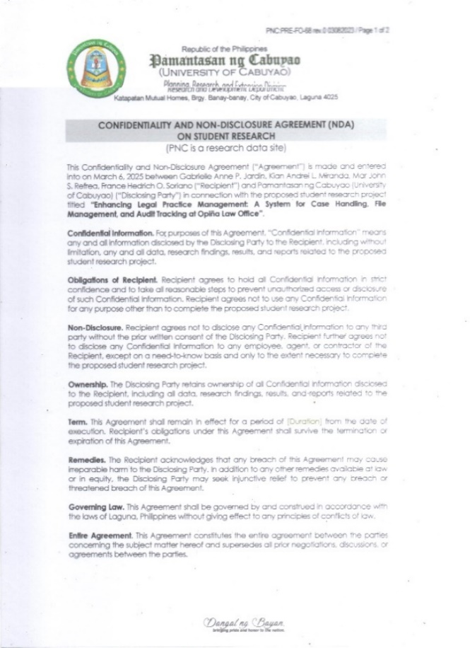

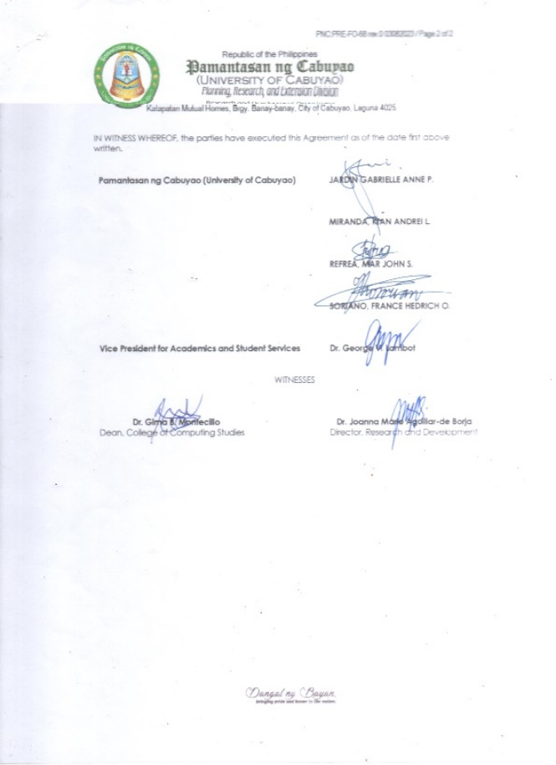

69








70




  - Letter for Client
71
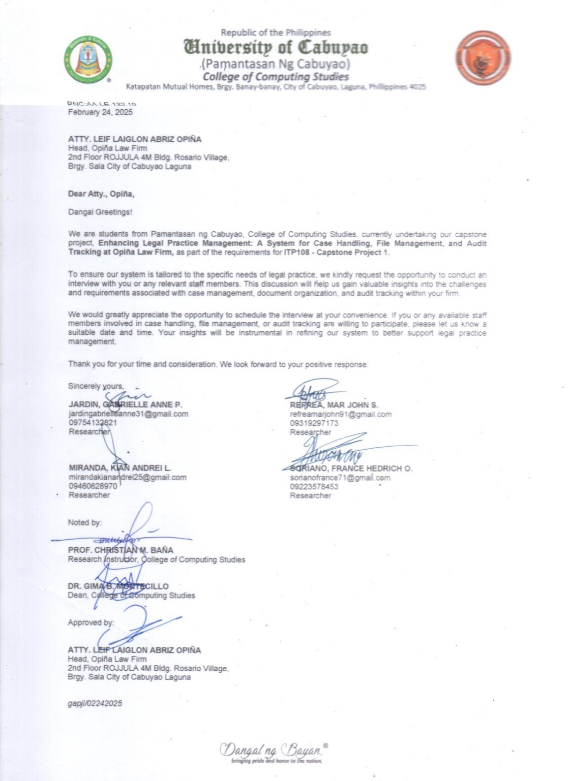

- Short Report of Plagiarism Software
72
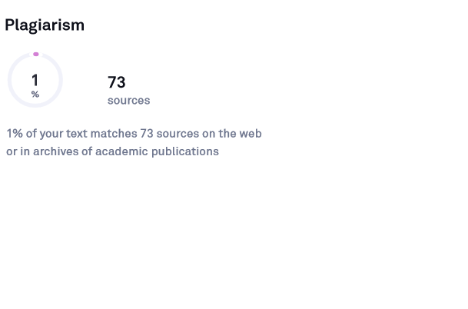
- Report of Language Software

